Goals:

* ~~figure out how system works~~
* read to understand how buck converter works
* ~~understand why there is ripple voltage with capacitor~~
* understand 2 techniques used to measure ripple voltage

2023-2024 spring capstone final report: <https://docs.google.com/document/d/1QNvqZRcIlr5oz7clWzOwtHOtSd97eKo5BvxzaM-GsSM/edit>

Github wiki: <https://github.com/Epsilon391/High-Frequency-Sampling-for-Circuit-Analysis>

09/04/2024:

* Buck converter
  + <https://en.wikipedia.org/wiki/Buck_converter>

09/05/2024:

* STM32 Cube IDE
  + Click download, accept, and then download doesn’t actually start
    - Solution: turn off all ad/pop-up blockers <https://community.st.com/t5/stm32cubeide-mcus/can-t-download-stm32cubeide/td-p/622045>
  + file:///Applications/[STM32CubeIDE.app/Contents/Eclipse/plugins/com.st.stm32cube.ide.documentation_2.2.400.202403111925/docs/DM00603738.pdf](http://stm32cubeide.app/Contents/Eclipse/plugins/com.st.stm32cube.ide.documentation_2.2.400.202403111925/docs/DM00603738.pdf)
  + STM32F103C8T6

09/06/2024:

* [Download folder from github](https://download-directory.github.io/?url=https%3A%2F%2Fgithub.com%2FEpsilon391%2FHigh-Frequency-Sampling-for-Circuit-Analysis%2Ftree%2Fmaster%2FProject%2520Files%2FCode%2520%2FBluePill_STM32)
* Practiced using STM32 Cube IDE and STM chip
  + Make light blink: <https://www.youtube.com/watch?v=MMGTHPxAS5s>
  + General steps:
    - 1. Create new project
    - 2. In IOC file, configure pin PC13 to be GPIO_Output
    - 3. Click “Save” icon in top left corner, confirm generating code
    - 4. Allow C/C++ perspective to open
    - 5. In main.c, go to the main method, and inside the while(1) loop, type:

| // Toggle PC13  **HAL_GPIO_TogglePin**(GPIOC,GPIO_PIN_13);  // Wait for 1s  **HAL_Delay**(1000); |
| --- |

* + - 6. Click “Build” hammer icon, or right click on project and click “Build Project”. Hopefully builds with no errors.
    - 7. Click “Run” green start button icon

Goal for week 3: get system running

* Need to get Buck converter board ✅
* Need to connect Pi to monitor and figure that out ✅

09/11/2024:

* What causes capacitor ripple voltage
  + <https://www.quora.com/What-causes-the-ripple-voltage-on-the-output-of-a-capacitor-input-filter>
  + <https://www.arrmaforum.com/threads/ripple-voltage-explained.49930/>

09/12/2024:

* Set up system
  + 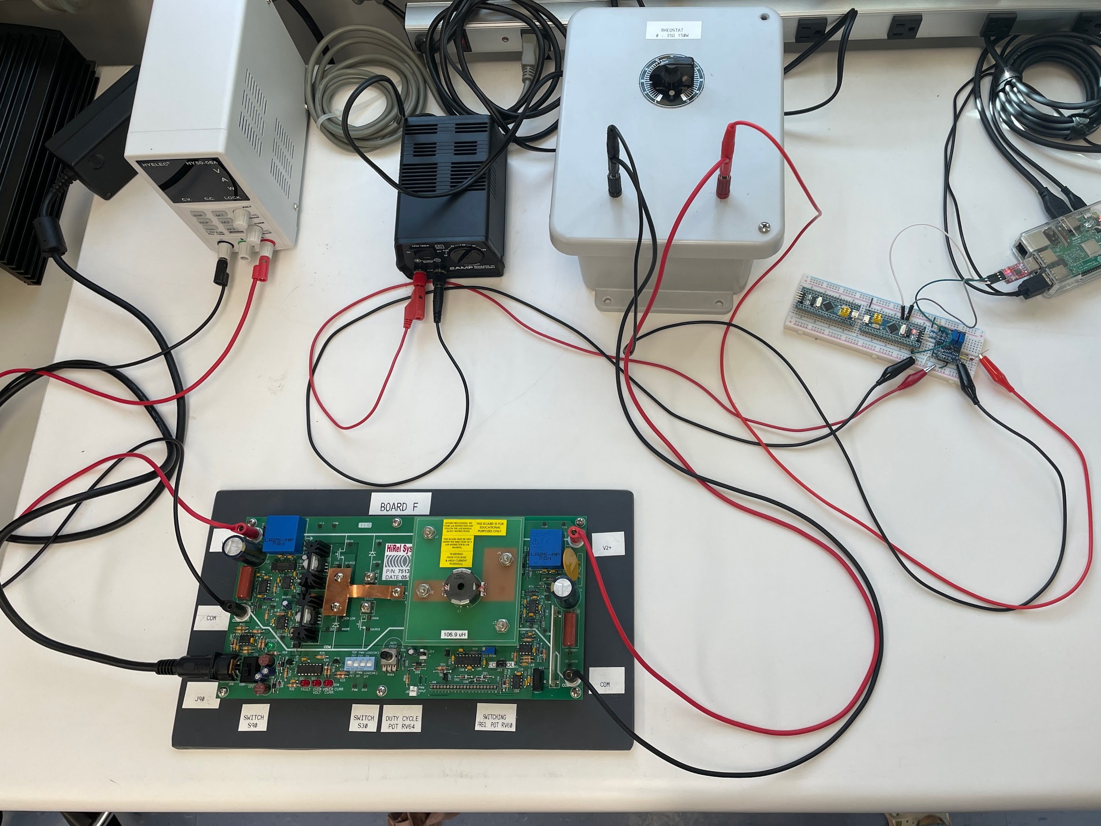
  + Need external power supply to power breadboard
* Python program to collect and graph points gathered by Pi: ECE_449_RW_to_CSV.py
  + To find file: find -iname ECE_449_RW_to_CSV.py
    - File located here: ~/Documents/ECE 449 Project Code/ECE_449_RW_to_CSV.py
    - Cd to file directory
  + Run program: python3 ECE_449_RW_to_CSV.py
* First attempt to run python program resulted in nothing. No data was written to data.csv, so I thought perhaps the STM32 board wasn’t programmed
  + Buck converter power supply at 24 V, 1.6 A, turned on
  + ADC chip power supply at 9 V, turned on
  + Everything appears to be connected properly
  + Programmed the STM32 board with the provided change_clock program
  + Discovered I never actually powered on the buck converter board LOL!
* *When powering everything on, remember that the buck converter board itself has a power switch*
* Second attempt to run python program
  + Buck converter power supply at 24 V, 1.6 A, turned on
  + Buck converter itself turned on
  + ADC chip power supply at 9 V, turned on
  + Everything appears to be connected properly
  + Runtime: 5 mins, program did not end, I force quit the program
    - Q: HOW LONG DOES THE PROGRAM TYPICALLY TAKE TO RUN?
  + Nothing written to data.csv again, wtf
  + I have to think that the STM32 board wasn’t programmed correctly? By me ofc
* Redownloaded and rebuilt STM32 program
  + 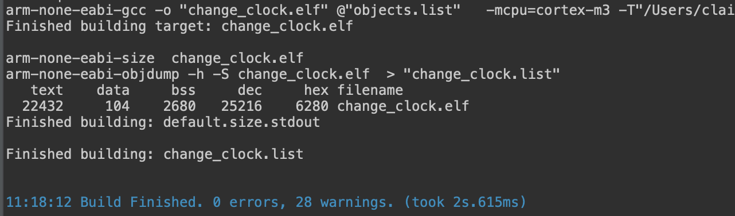
  + Gonna ignore the warnings for now and try to upload it for the third attempt
* Third attempt:
  + Ran for 7 mins, still no output, nothing written to data.csv, wtf again !!
  + I still think maybe the STM32 program isn’t uploading properly, not sure how to go about that
* Things that could be wrong:
  + STM32 board could be programmed incorrectly
  + Wired connections between boards could be wrong
  + Running wrong voltage/current into buck converter?
    - Did not even mess with duty cyle on board, maybe I should ?
  + User error is big big possibility
  + Maybe I’m running the python script incorrectly?

09/13/2024:

* Buck converter duty cycle:
  + 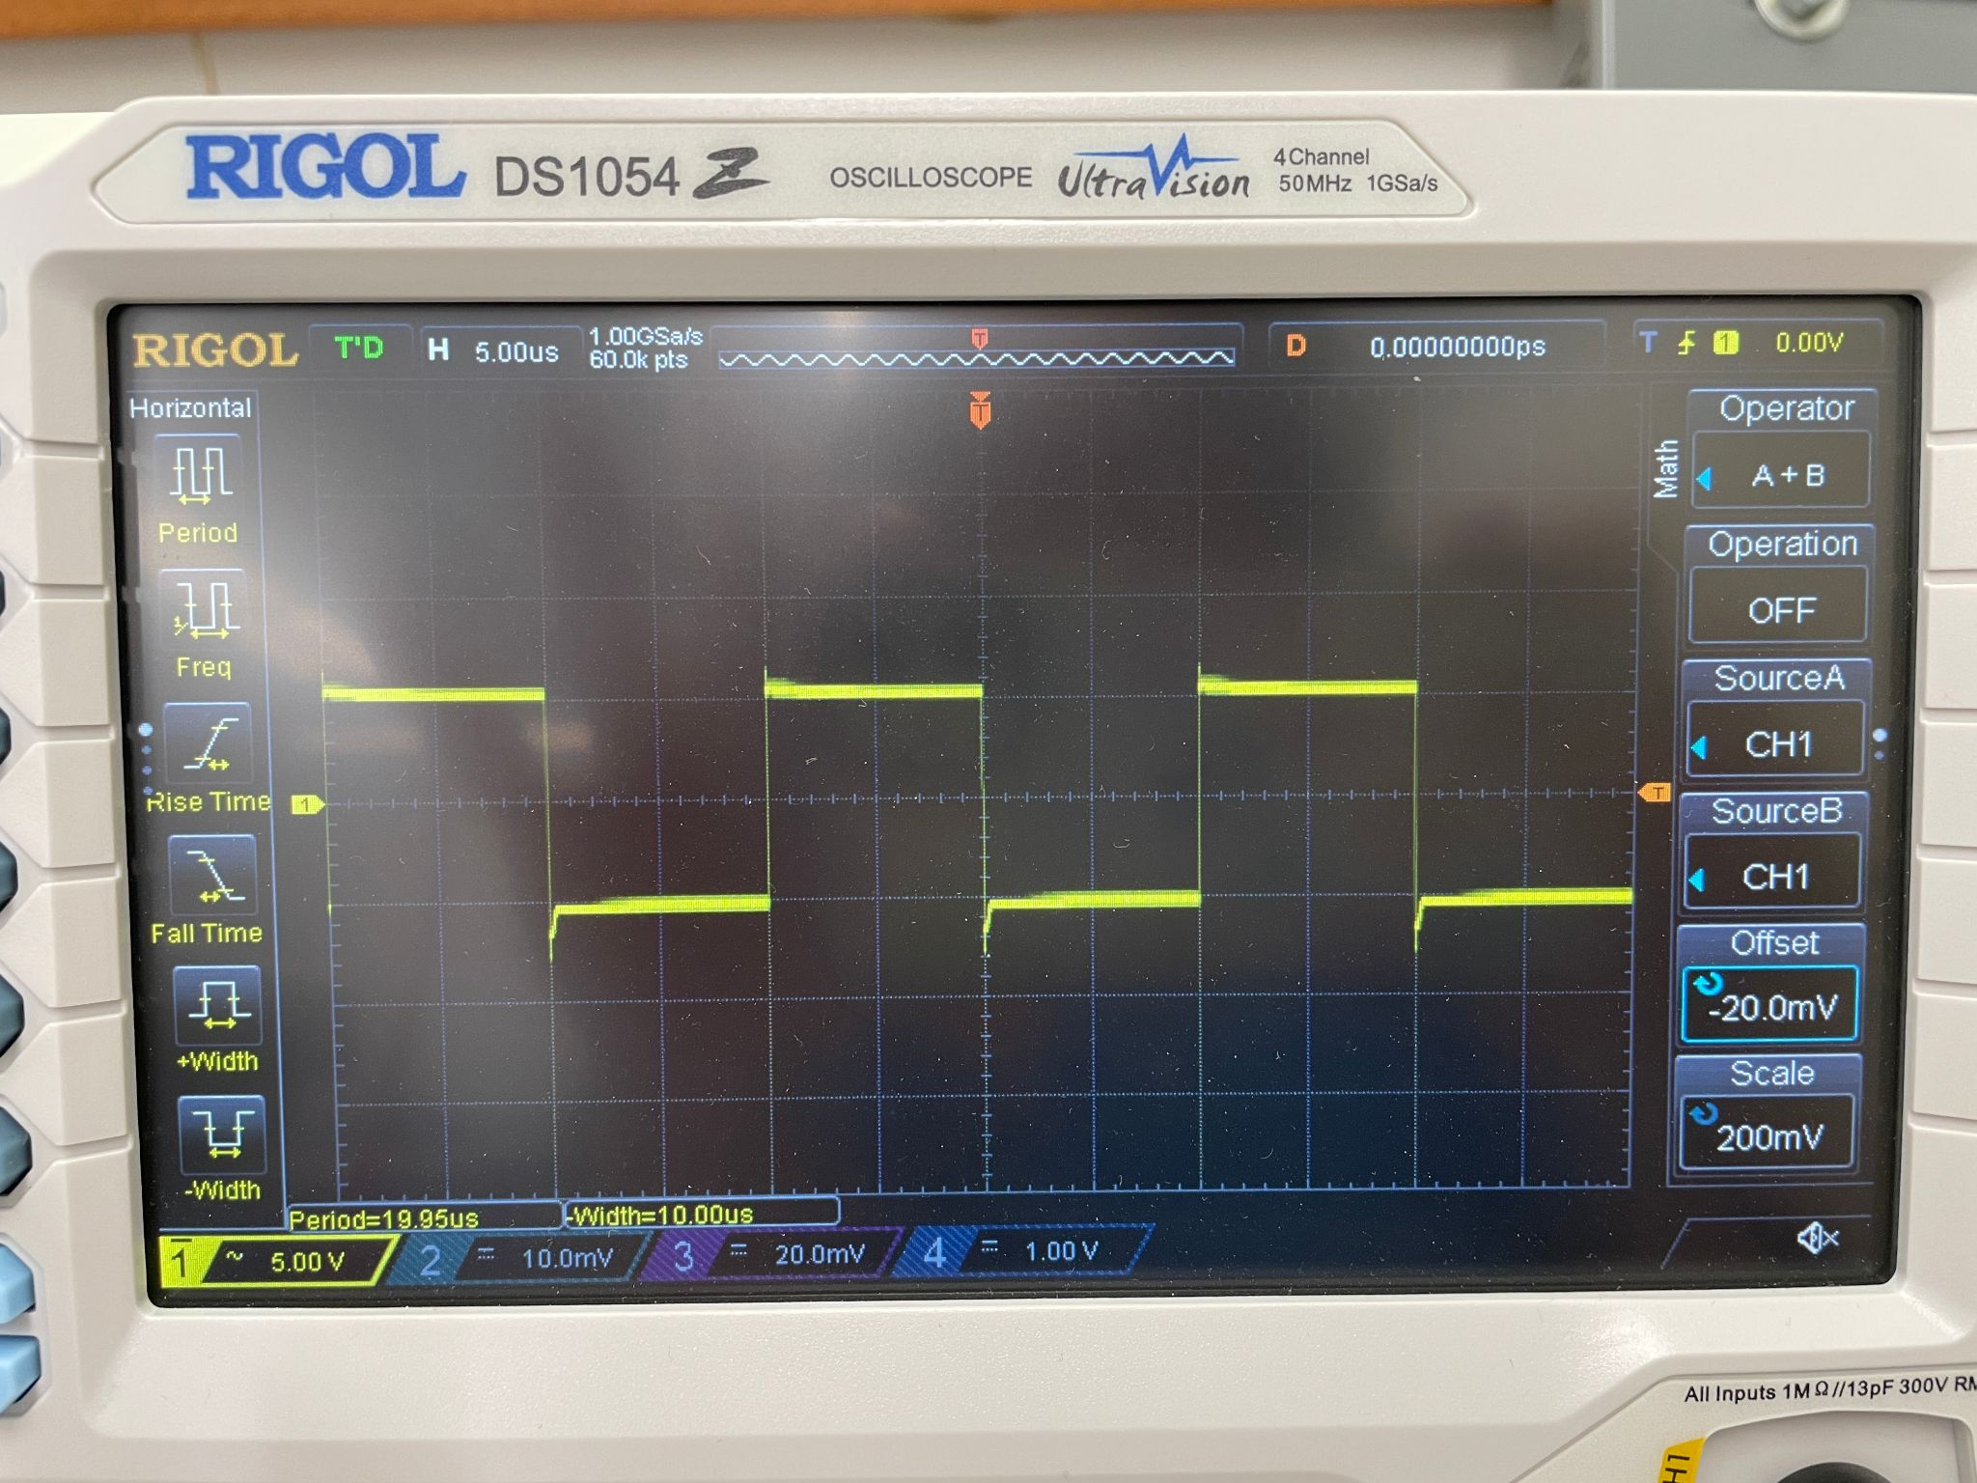
* Jess’ 4 channel oscilloscope: <https://assets.testequity.com/te1/Documents/pdf/rigol/Rigol-DS1054Z-Specification.pdf>
* Buck converter board: <https://drive.google.com/drive/folders/1aJg81HhglCsnw4HQNvCHoP6H5GllX6lW>
* Input voltage??
  + 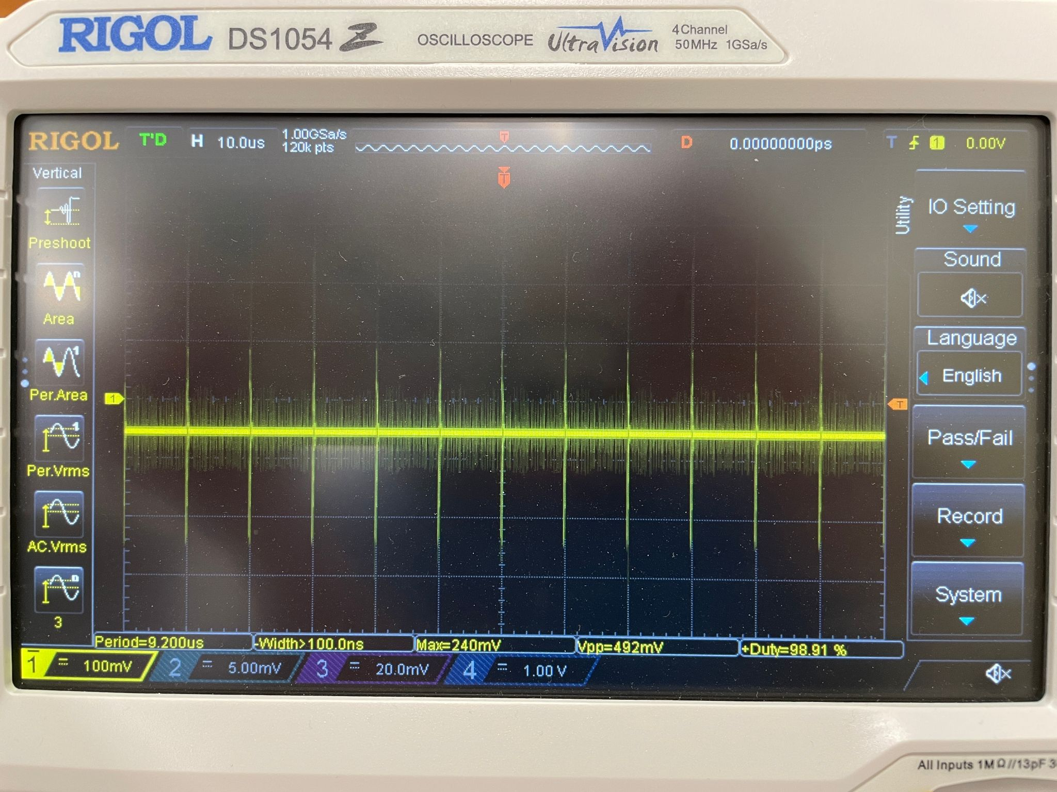

9/16/24 meeting with Dr. Scott:

* Try feeding STM32 board DC volt (3.3 V) to see if it measure
  + Power supply in the 304 lab that i might be able to use
* Contact financial aid
  + Let dr scott know how it gets from A to B

09/17/2024:

* Got 2 multimeters and new power supply from Dr. Scott
* Testing little power supply with multimeter, not seeing any DC voltage
* Tested variety of leads and the old and new power supplies
  + Some leads can accurately read output voltage from new power supply, but same leads do not see any output from the old power supply
    - **Old power supply not outputting voltage??**
  + **Some leads are faulty as well**
  + Faulty and good leads have been labeled and left on desk for later
* Using new power supply and good leads, i was able to accurately read input and output voltages through buck converter!!!
* Made sure voltage is going through buck converter to other circuit components successfully
* Attempting another run of the python script
  + ACT light on Pi was blicking for a moment but then i breathed on it and it stopped lol
    - Omg it starting blinking again for a couple blinks and then stopped again
    - “While booting, the ACT LED should blink in an irregular pattern, indicating that it is reading from the card. If it starts blinking in a regular, Morse code-like pattern, then it is signaling an error. If it blinks just once, it could be that you have a Raspberry Pi with SDRAM from Micron.” <https://support.pishop.ca/article/33-raspberry-pi-act-led-error-patterns>
    - 11111111111111111 -> 17 blinks
    - 1111111 1 1111111111 -> 18 ?
  + Nothing on UART to USB blinking… should it?
  + Runtime: 10 mins 15 s
  + NOTHING WRITTEN TO DATA.CSV >:((((
* Ideas if the run doesn’t work:
  + Add a blinking light part to the clock code for the STM32 board so I can visually verify that the code is on the board
  + See if the UART to USB chip should be blinking during transmission
  + Check that STM32 board is correctly connected
    - Common ground?
      * I’ll feel silly if this is the main issue

09/18/2024:

* Added blinking light to STM32 board main while loop after 1 buffer acquisition for some visual feedback
* Tried uploading program and then running program, still no output
* Removed pin declaration for ADC0 because it’s not being used, reuploaded program
* Tried putting 3 V into STM32 board instead of the buck converter -> amplifier -> STM32, and then tried running python program
  + Believe it or not, the python program worked!!!
  + 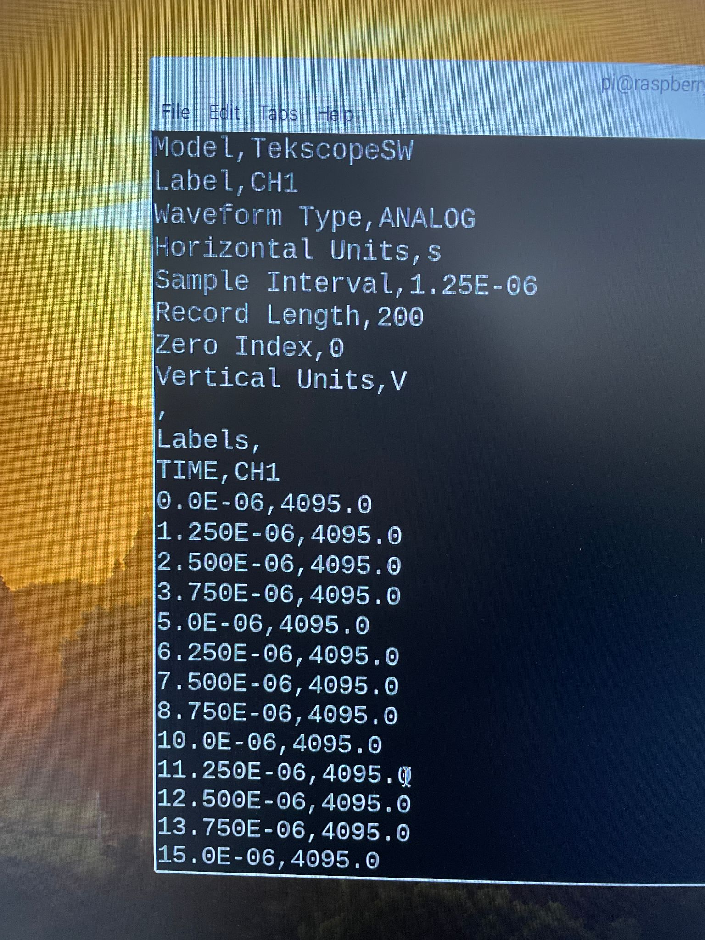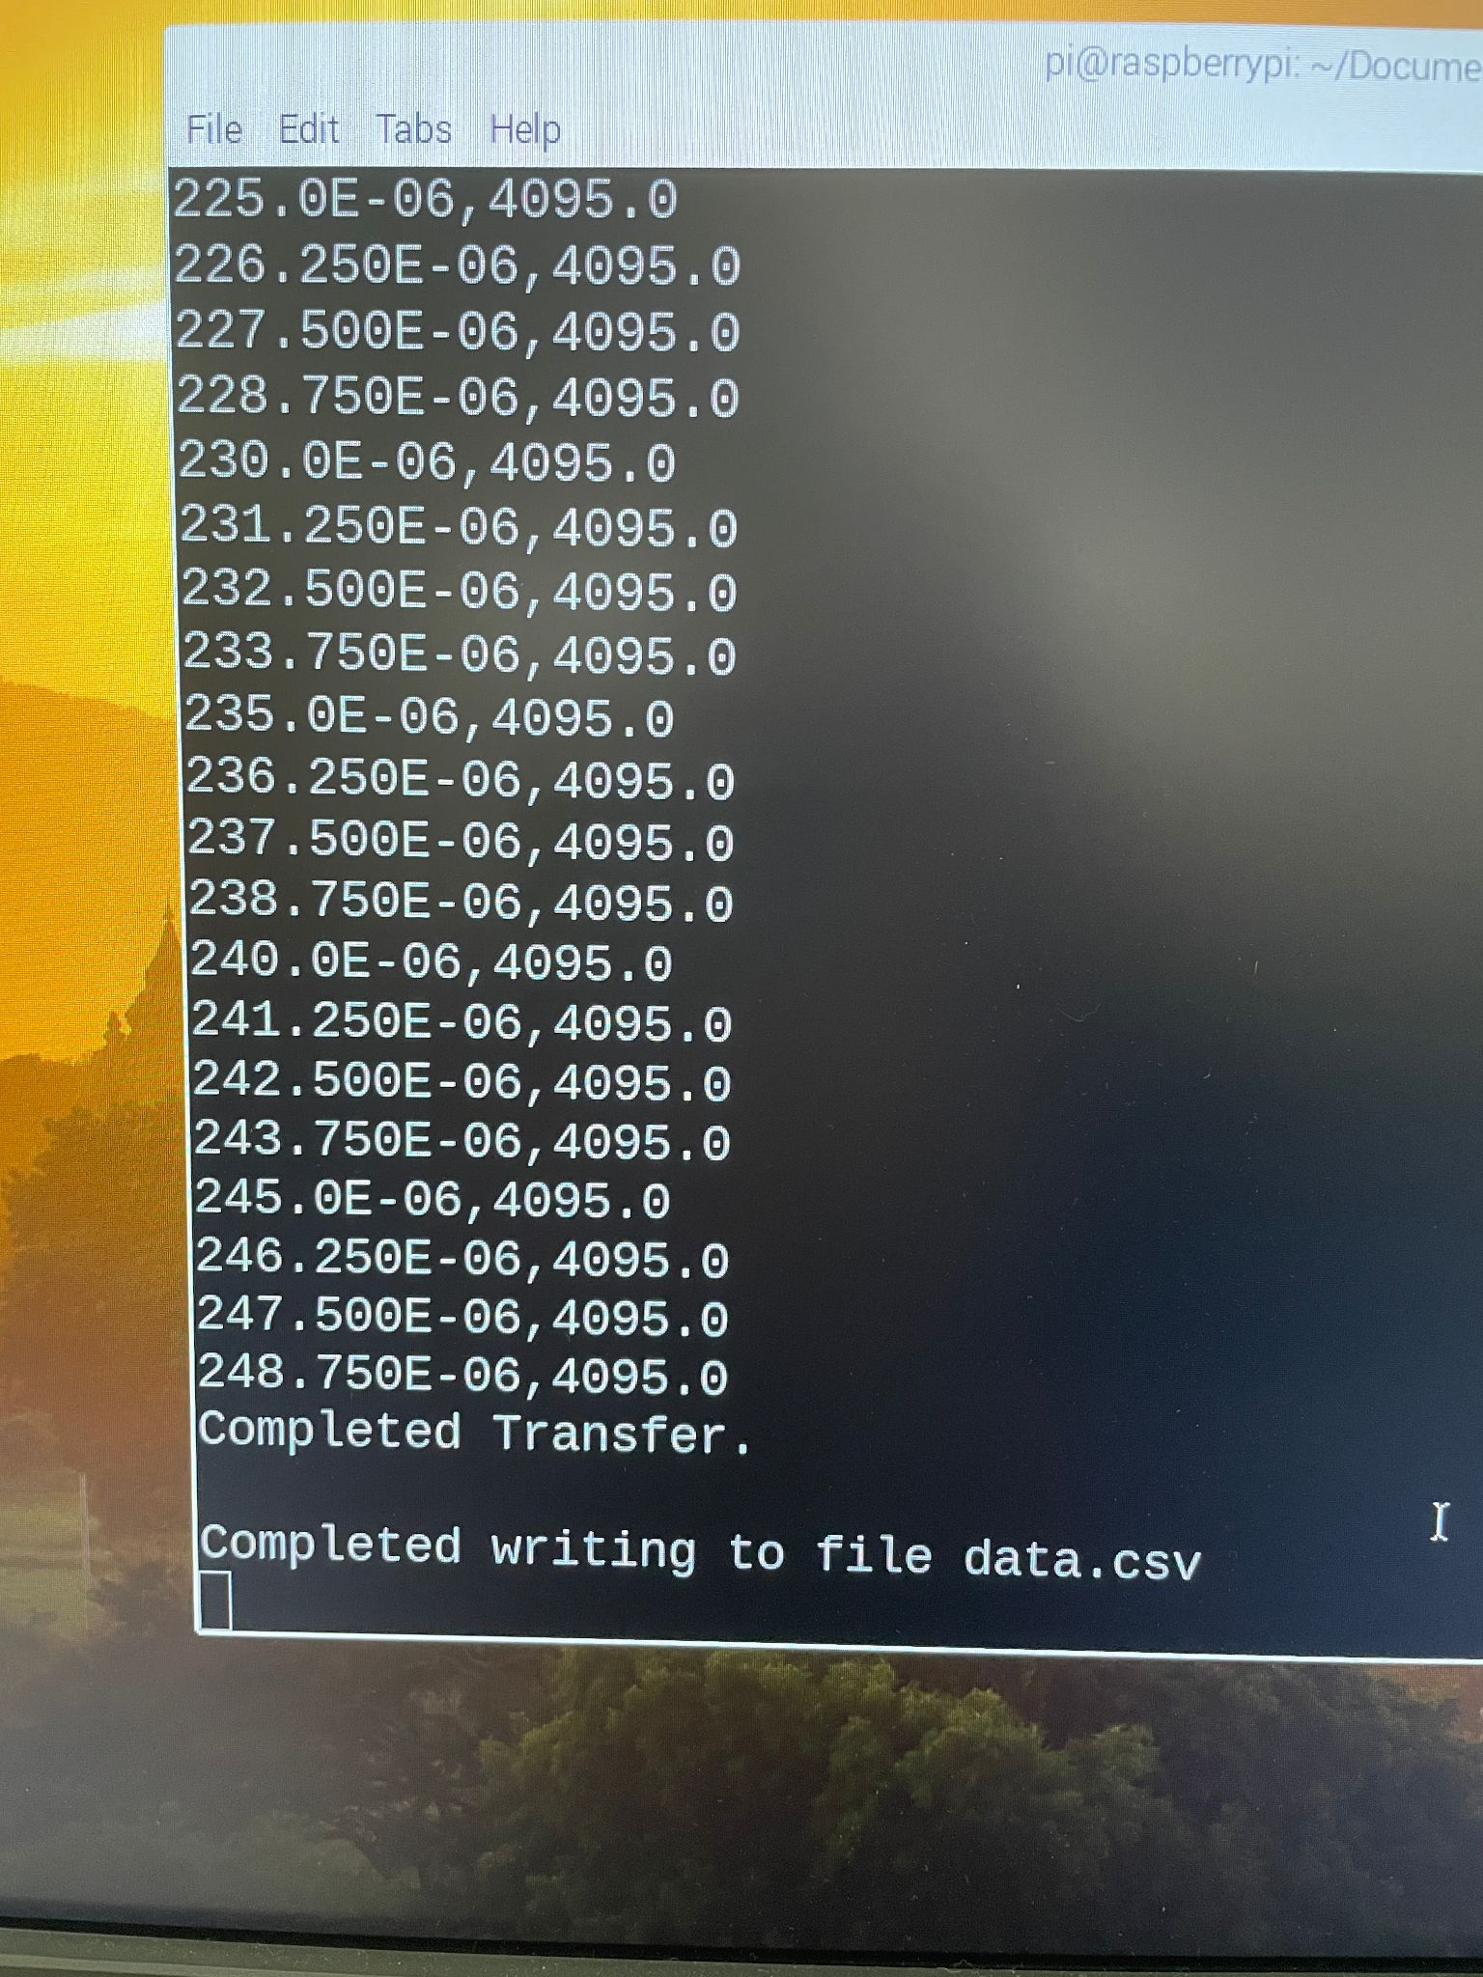
  + 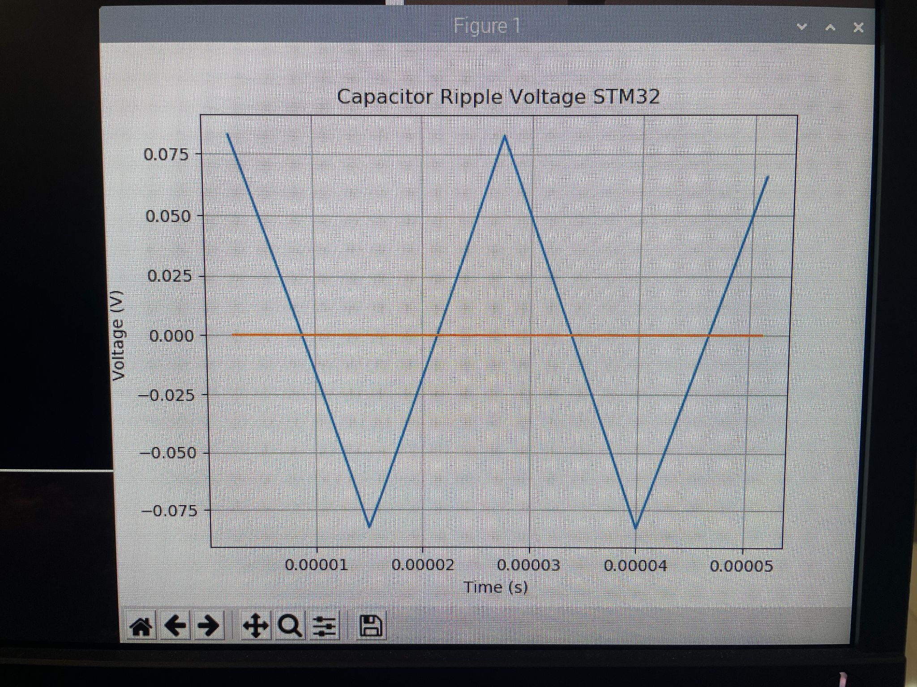
  + I’ll call this a success!!
  + So i think maybe i was putting too high of a voltage into the STM32??
    - Review amp build and connection from amp to STM32
  + Light on UART to USB flashed during transfer
* Checked amp input/output - matches closely to report image
  + 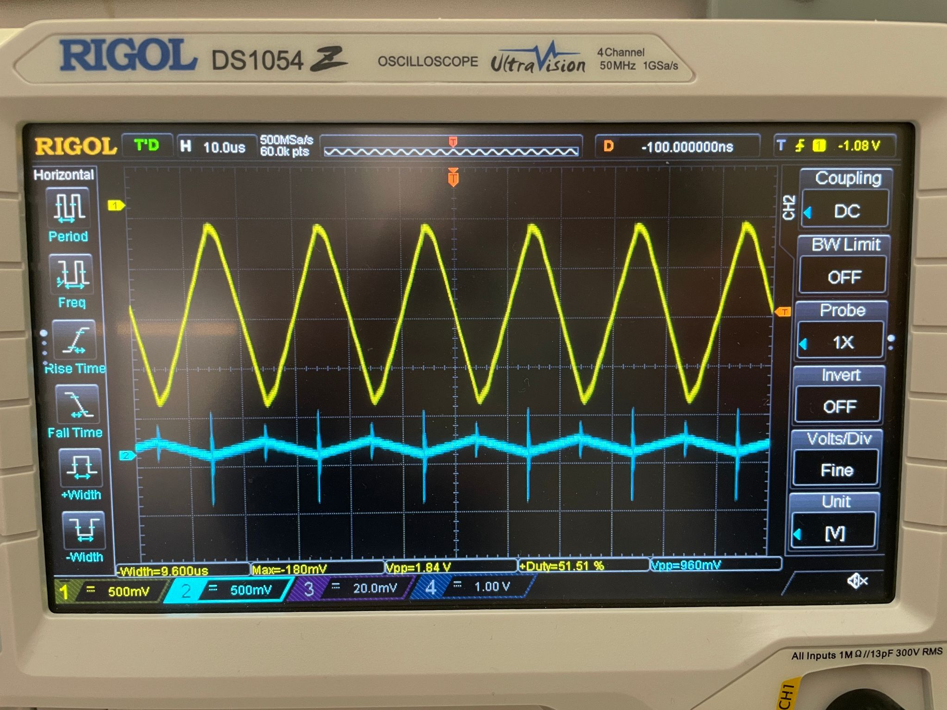
    - Blue = high pass filter output
    - Yellow = amp output
  + 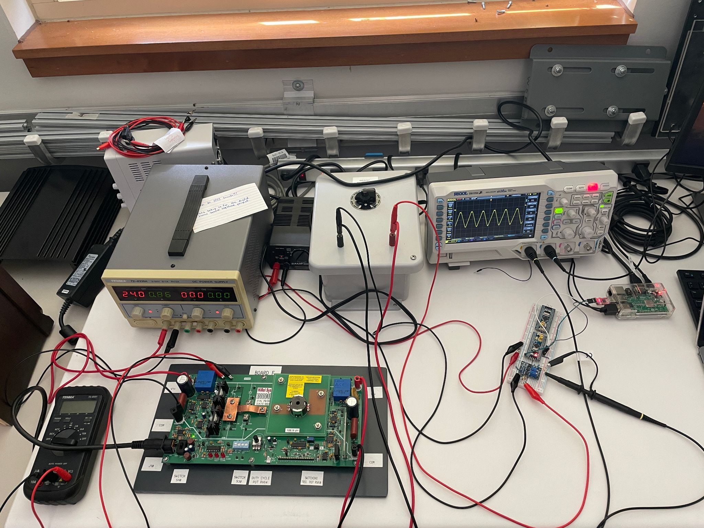

Meeting with dr scott:

* Look into STM32 manual and see what happens if it’s over/under voltaged
* Does the amplifier go negative?
  + Verify that it does not go negative
  + Investigate amp output voltage and figure out how to keep it positive
* Use function generator to test STM32
  + 1-2 V, triangle wave, same freq.
* Eventually will have to do literature review of reliability in space applications
  + Could be cool to look into specific ship
    - Voyager 1 or 2
      * See what kind of reliability went into that
      * Isotope power supplies, thermo electric coolers
  + Need to tie it back to NASA somehow
  + Maybe international space station

09/19/2024:

* Tried to run the python script first thing to have it run for an hour like Alecea said it usually took, and now it won’t even run. I enter ‘s’ and then it does the thing like when i quit the process early
* Verified that the 3 volt STM32 input still works, it does
* Tested Jess’ oscilloscope with the function generator, channel 1 inverts the signal across the x-axis, channels 2 and 3 are consistent with a lab oscilloscope and what I would expect, i did not test channel 4
  + 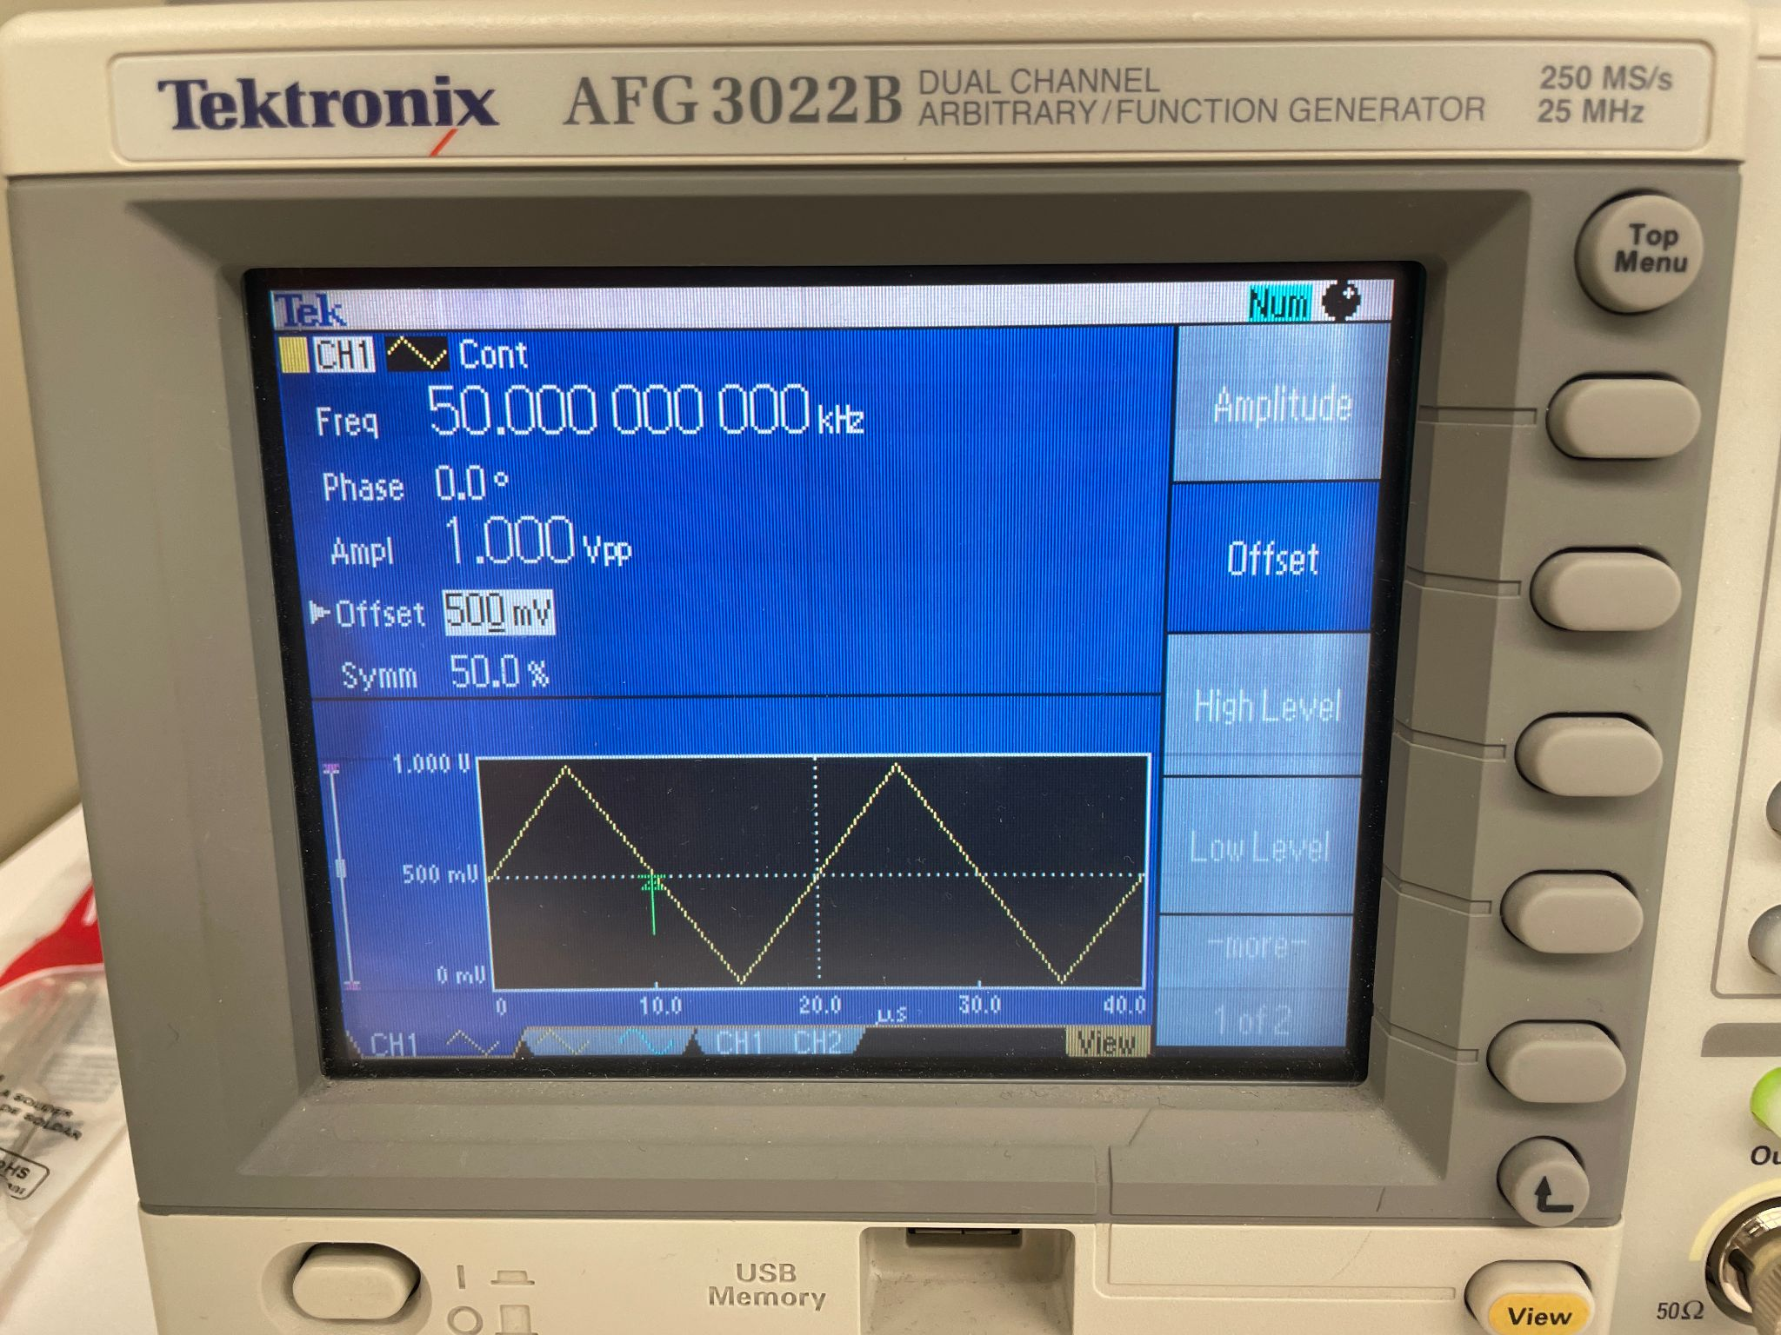: signal gen
  + 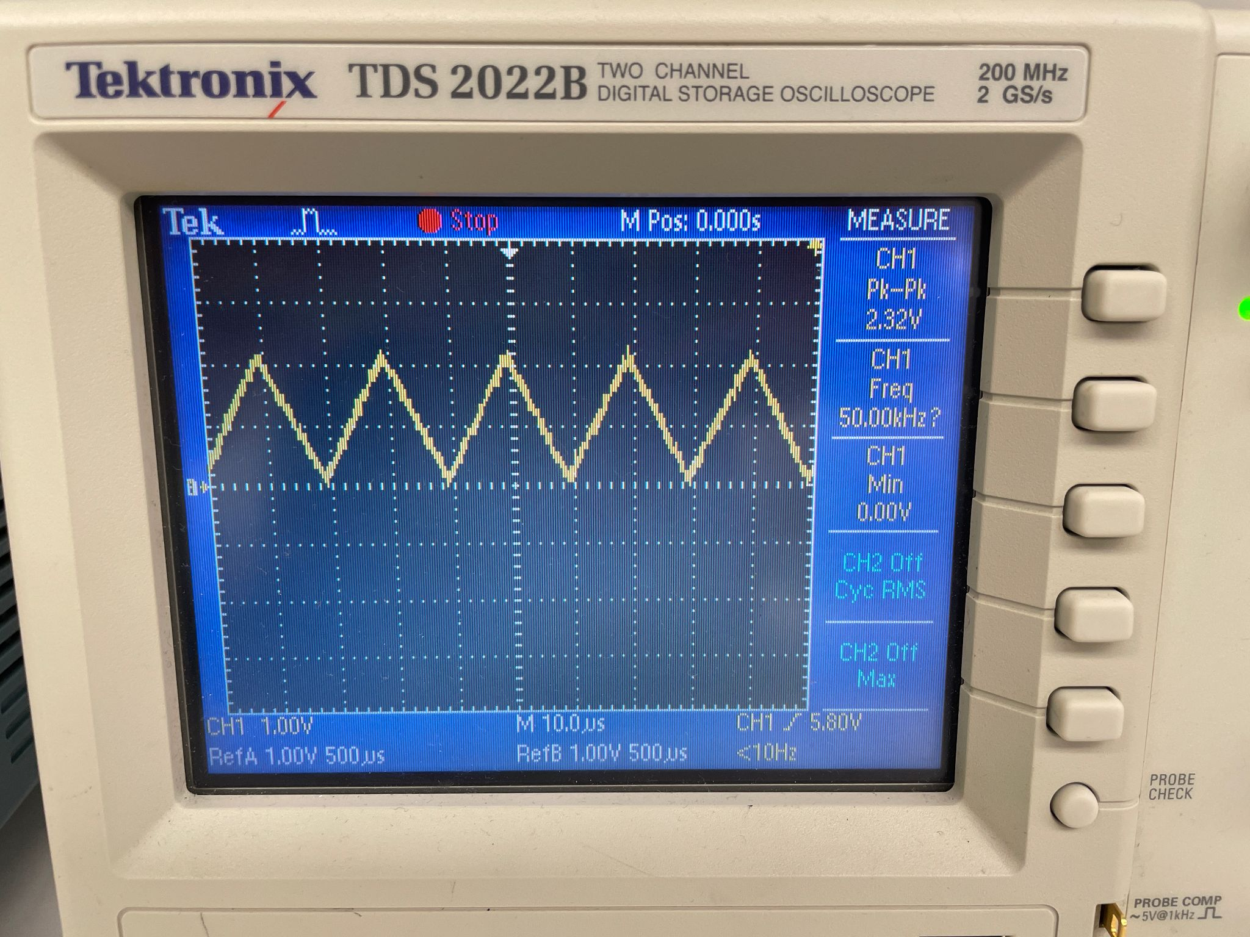: lab oscilloscope
  + 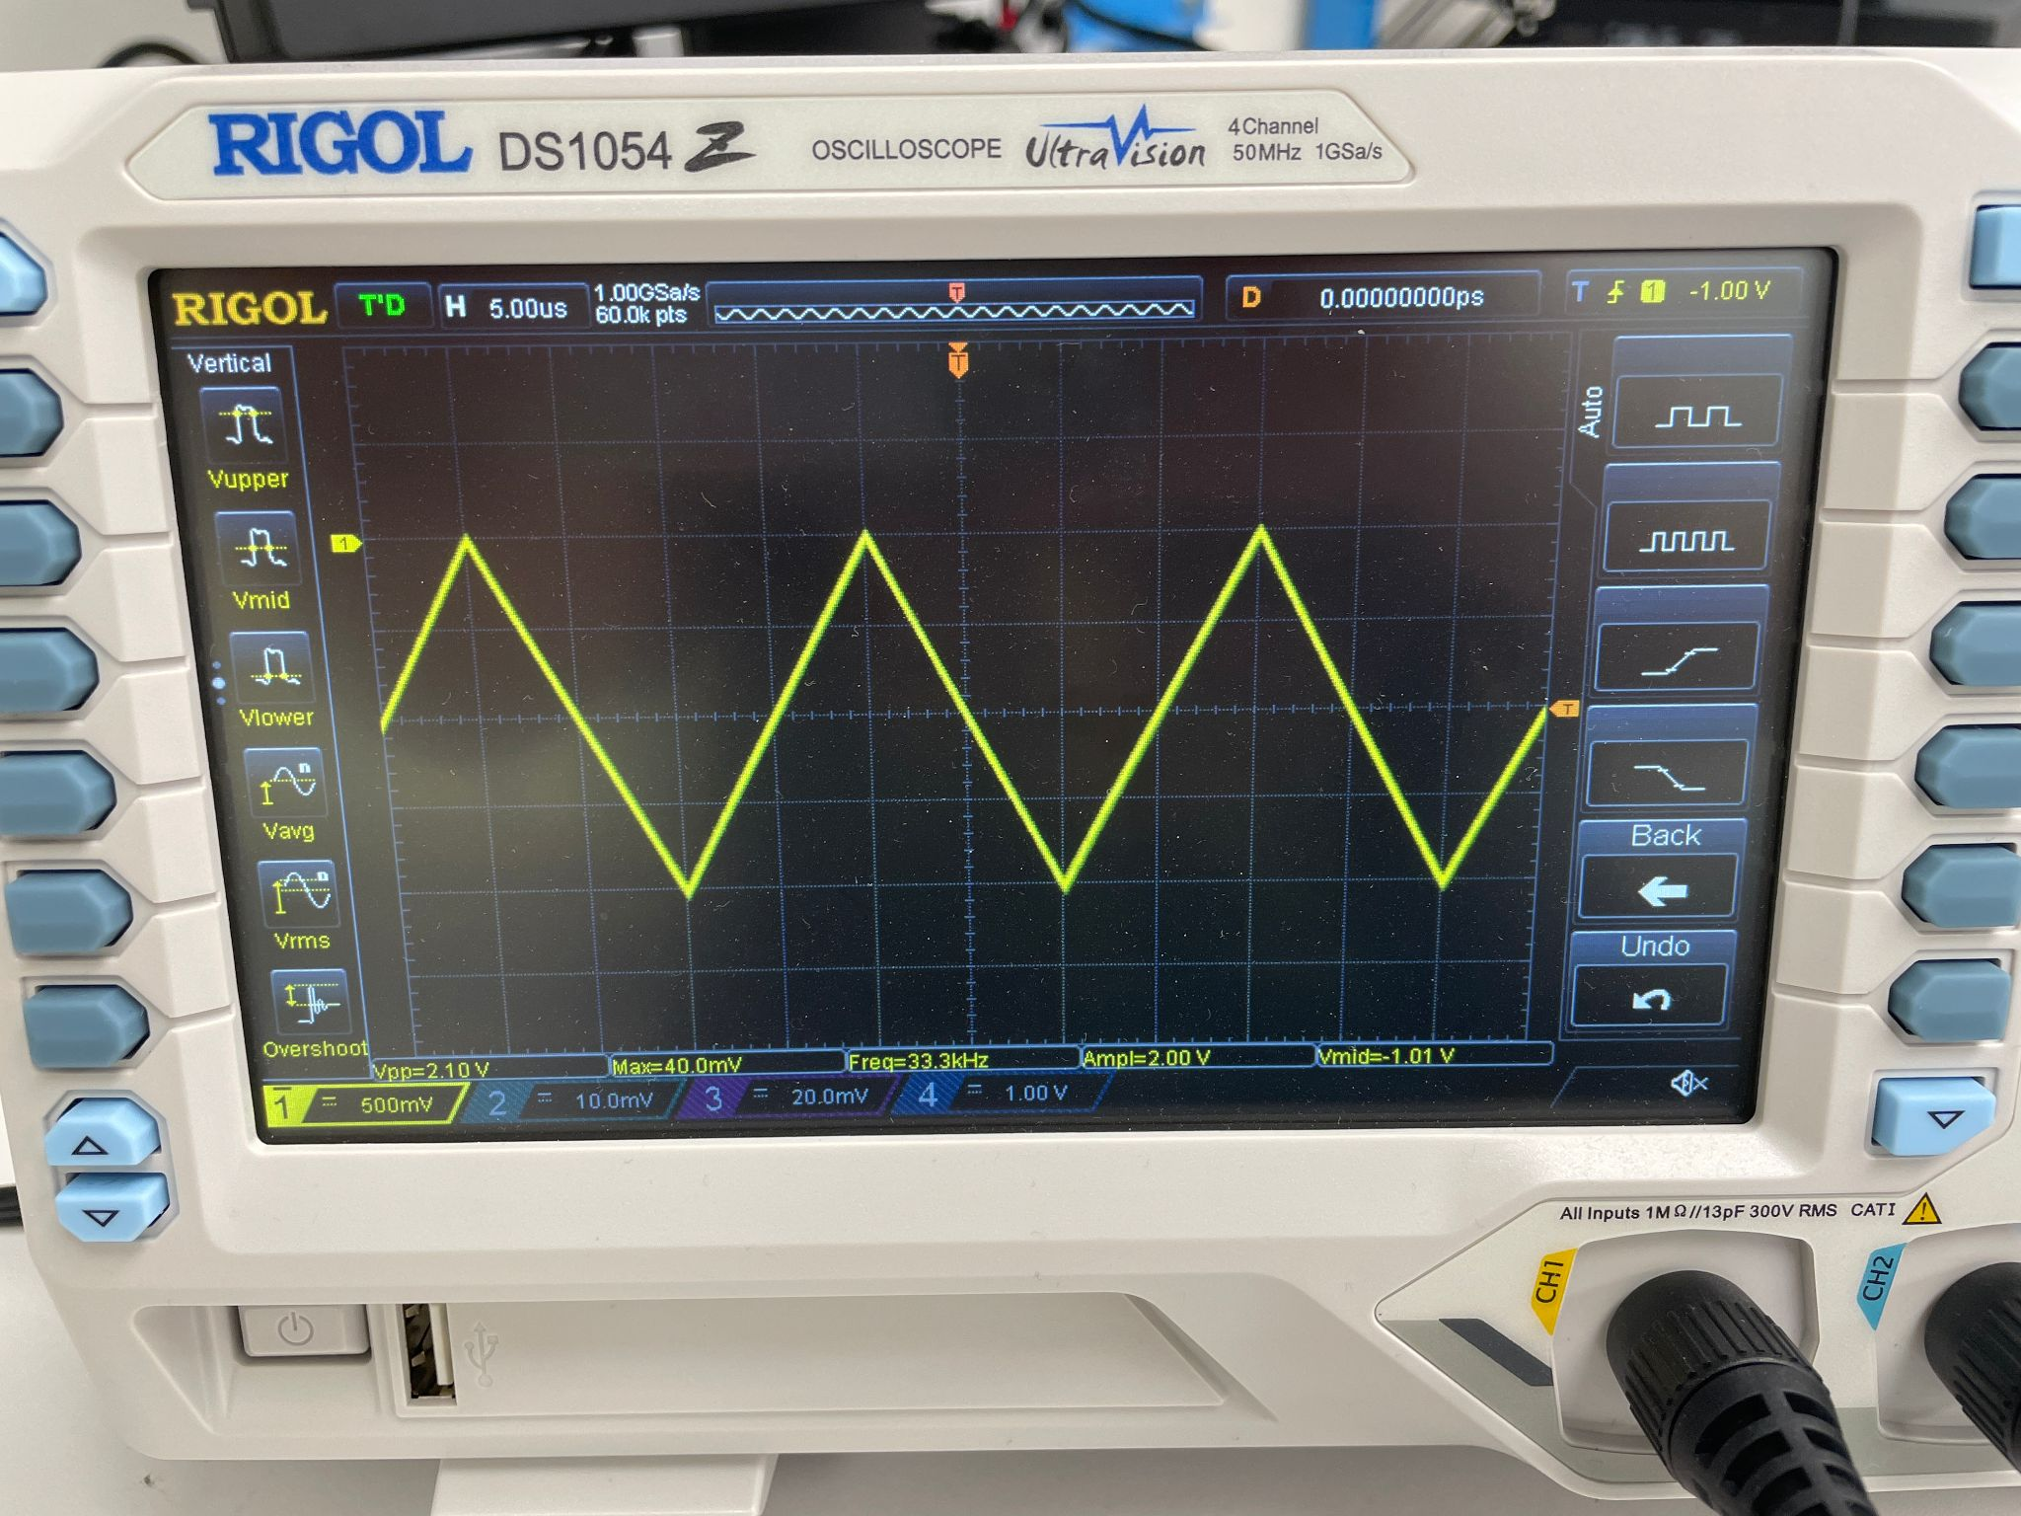: Jess oscilloscope ch 1
  + 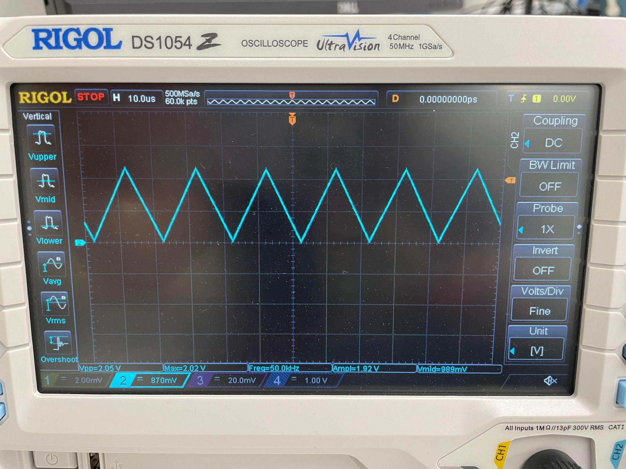: Jess oscilloscope ch 2
  + 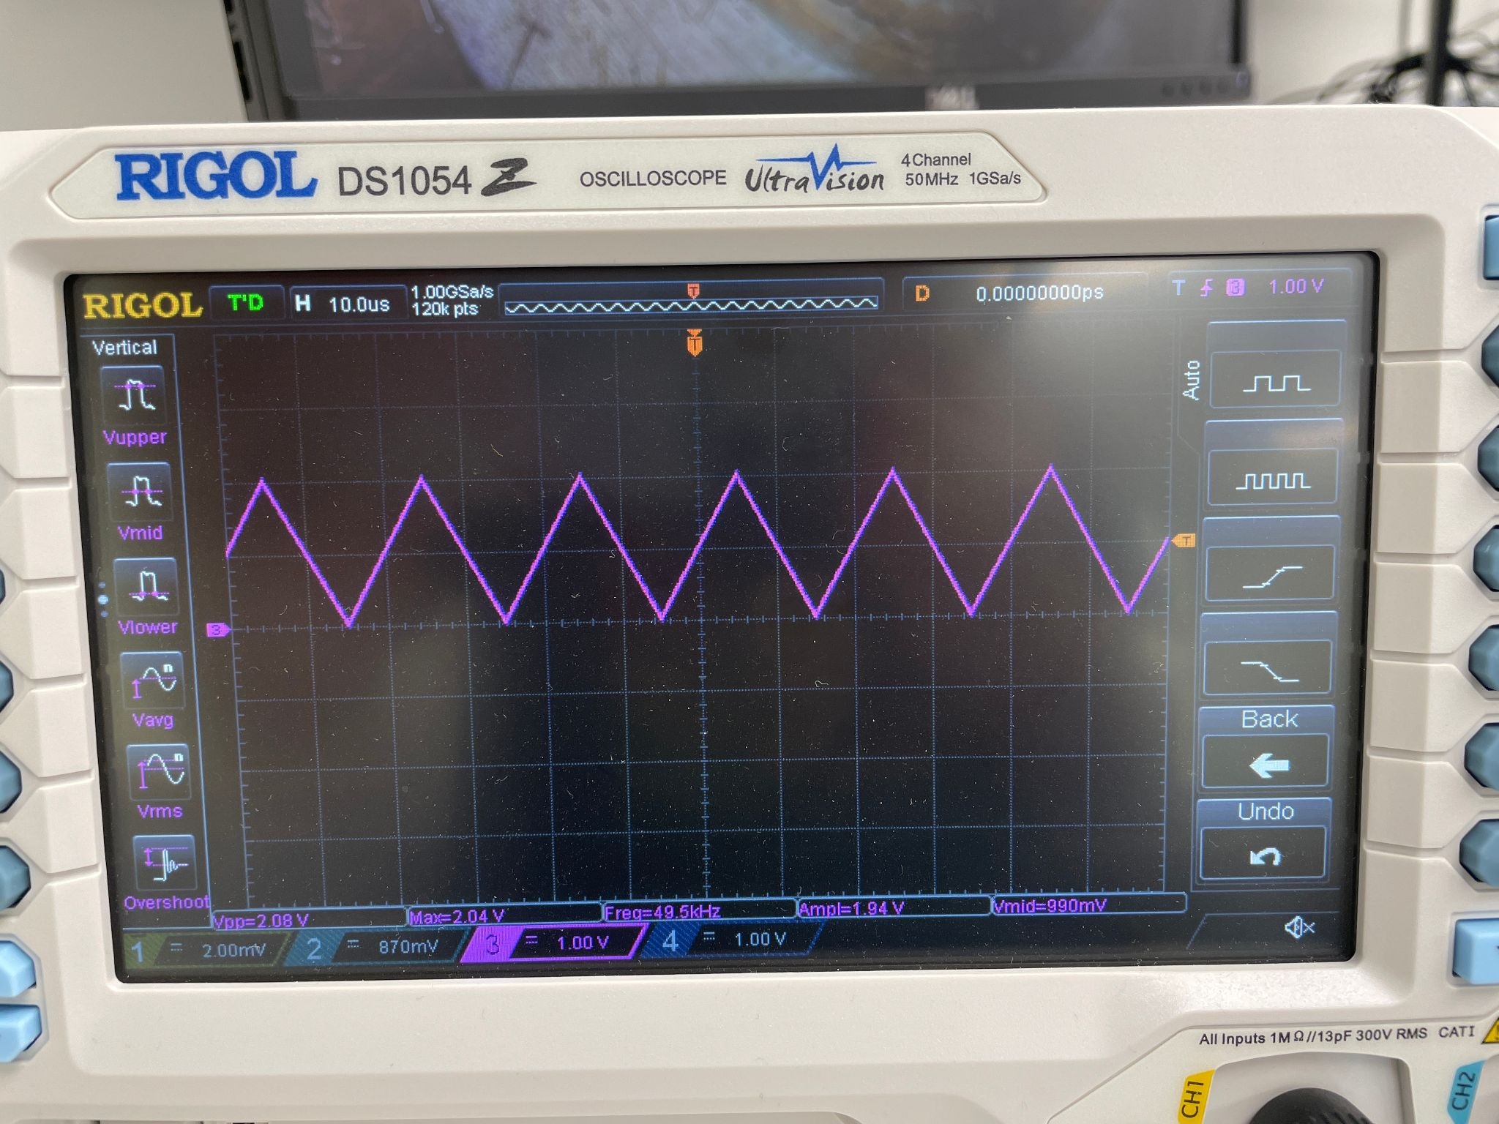: Jess oscilloscope ch 3
* By using the supposedly trustworthy channels 2 and 3, i saw that the output of the amplifier was HUGE, like 12 V or something.
  + 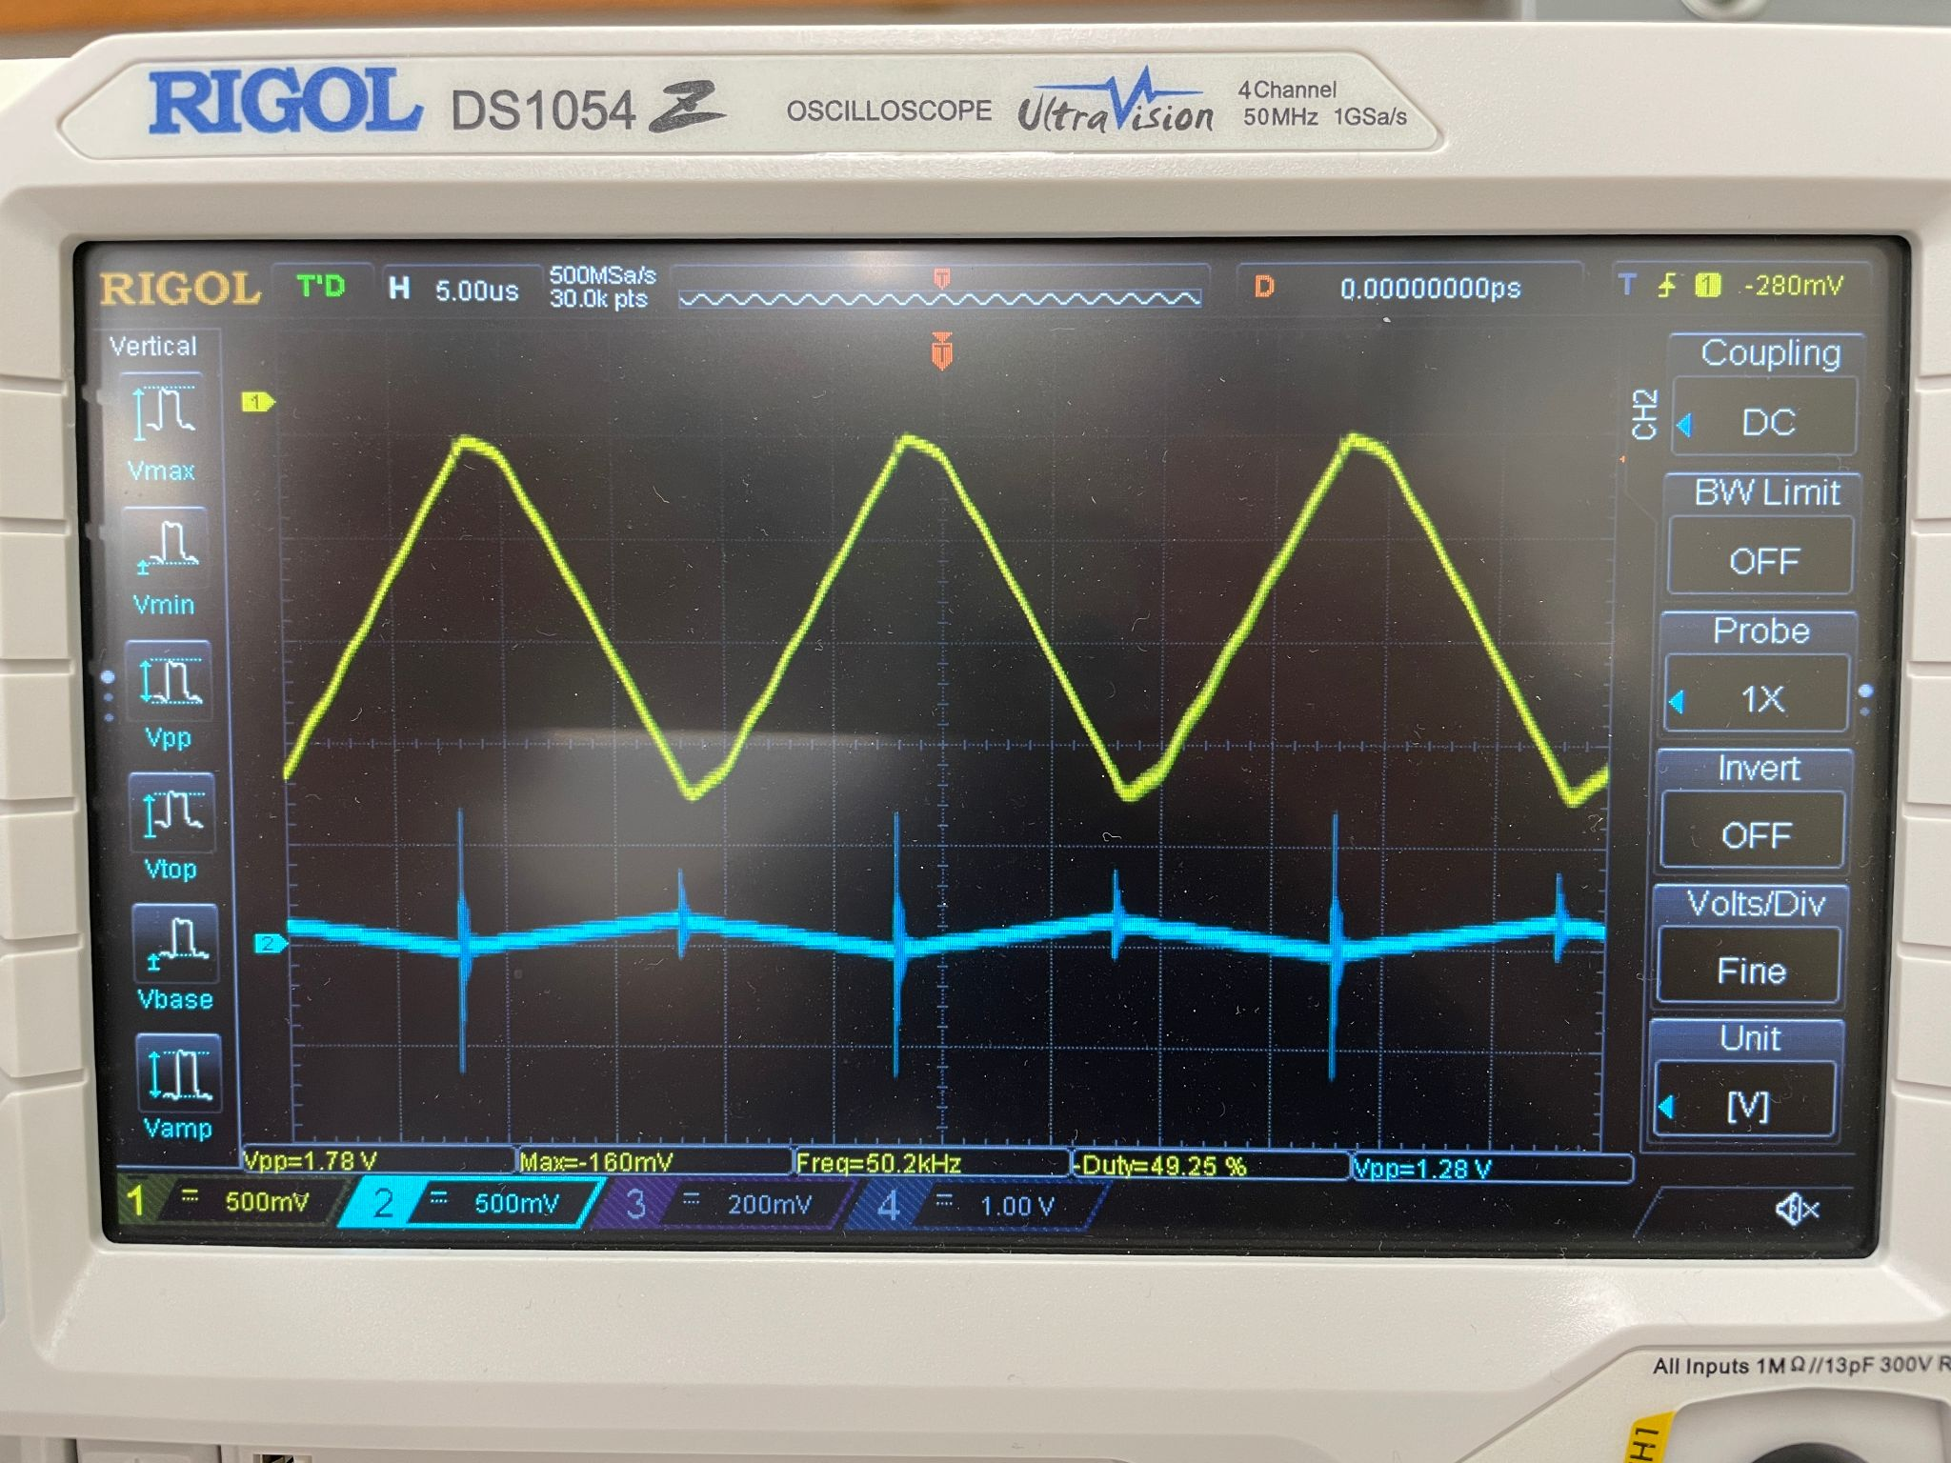
  + 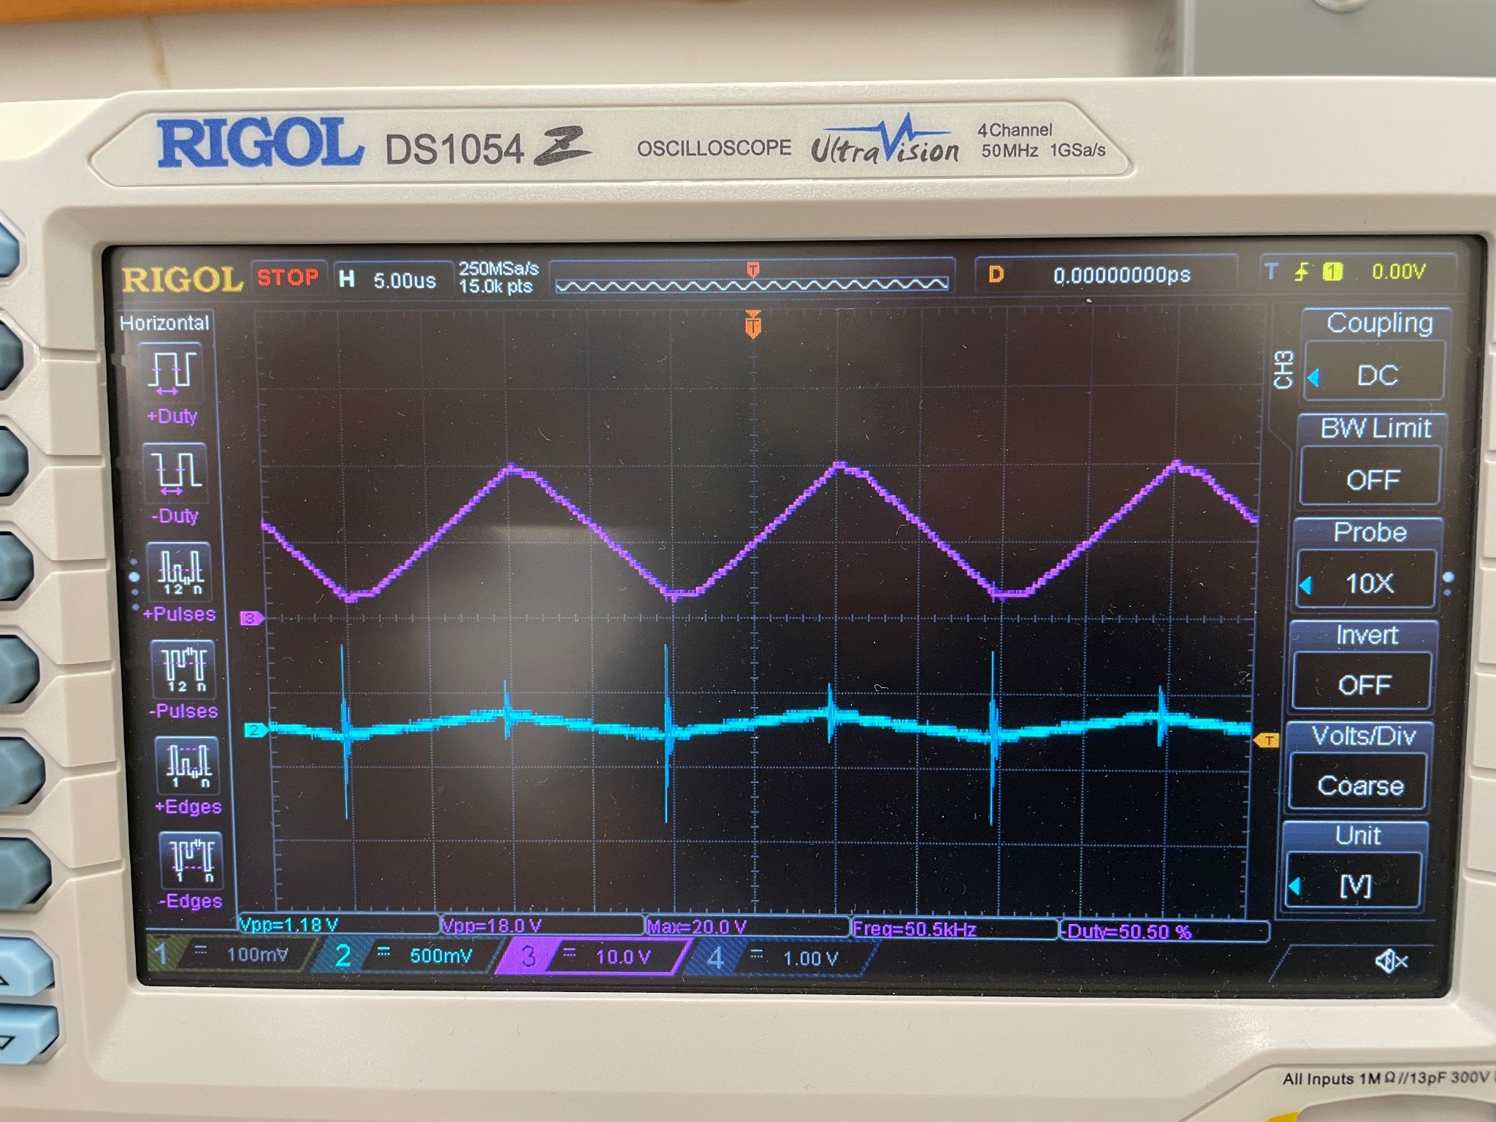
    - YELLOW AND PURPLE ARE MEASURING SAME THING!! WTF!!!!
  + I tried turning the gain pot on the amp but i couldn’t get it down low enough to match the picture in last year’s report
* Tomorrow: try signal gen into STM32 like dr scott suggested

09/20/2024:

* I was not actually sending 18 V into the STM32, I think I def would’ve fried it if I did. The probe was 10x multiplied. So I was sending 1.8 V into the STM32, which is below the 3.3 V max. All oscilloscope issues have been figured out
* Also Jess fixed ch 1, it was inverted and on course volts/div
* Finally some good fking signal
  + 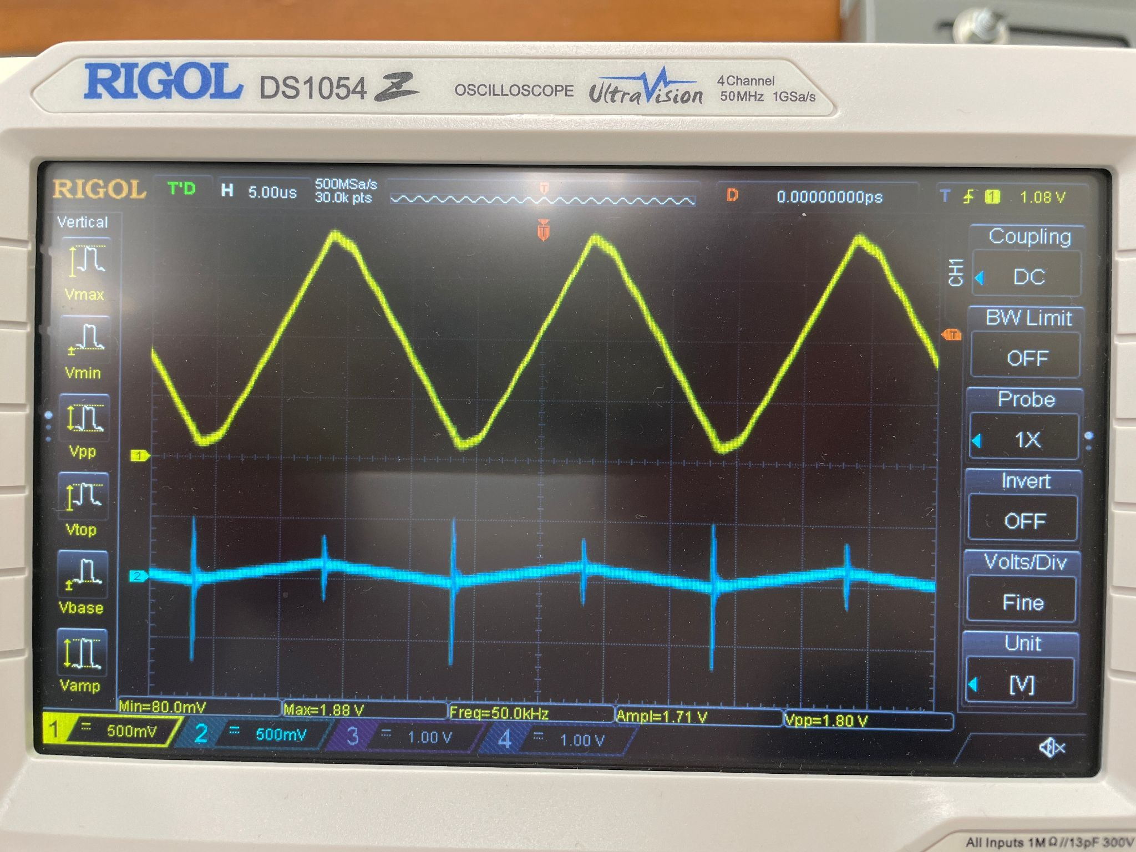
  + 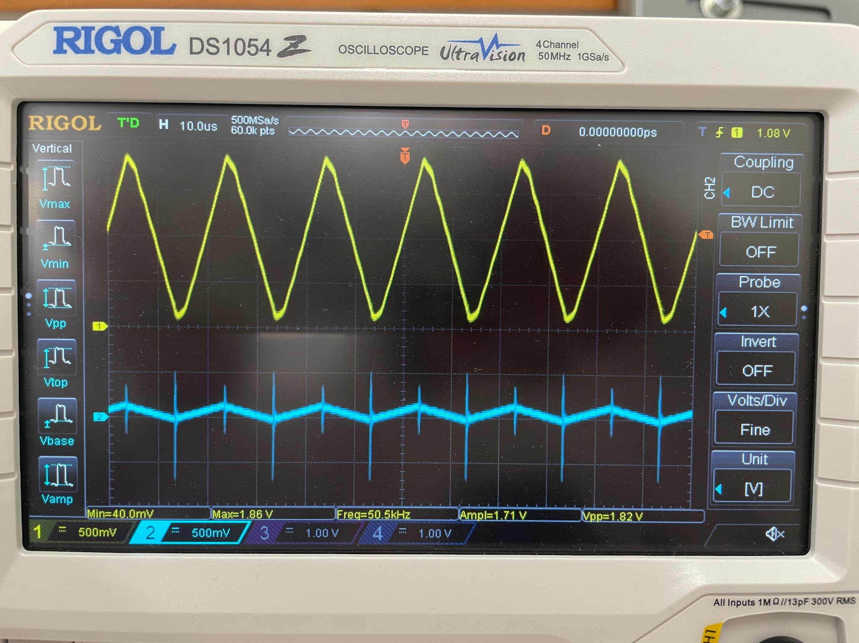
* Now why tf won’t the python script work
* Python script test run #??:
  + Runtime: 24 mins
  + UnicodeDecodeError
    - 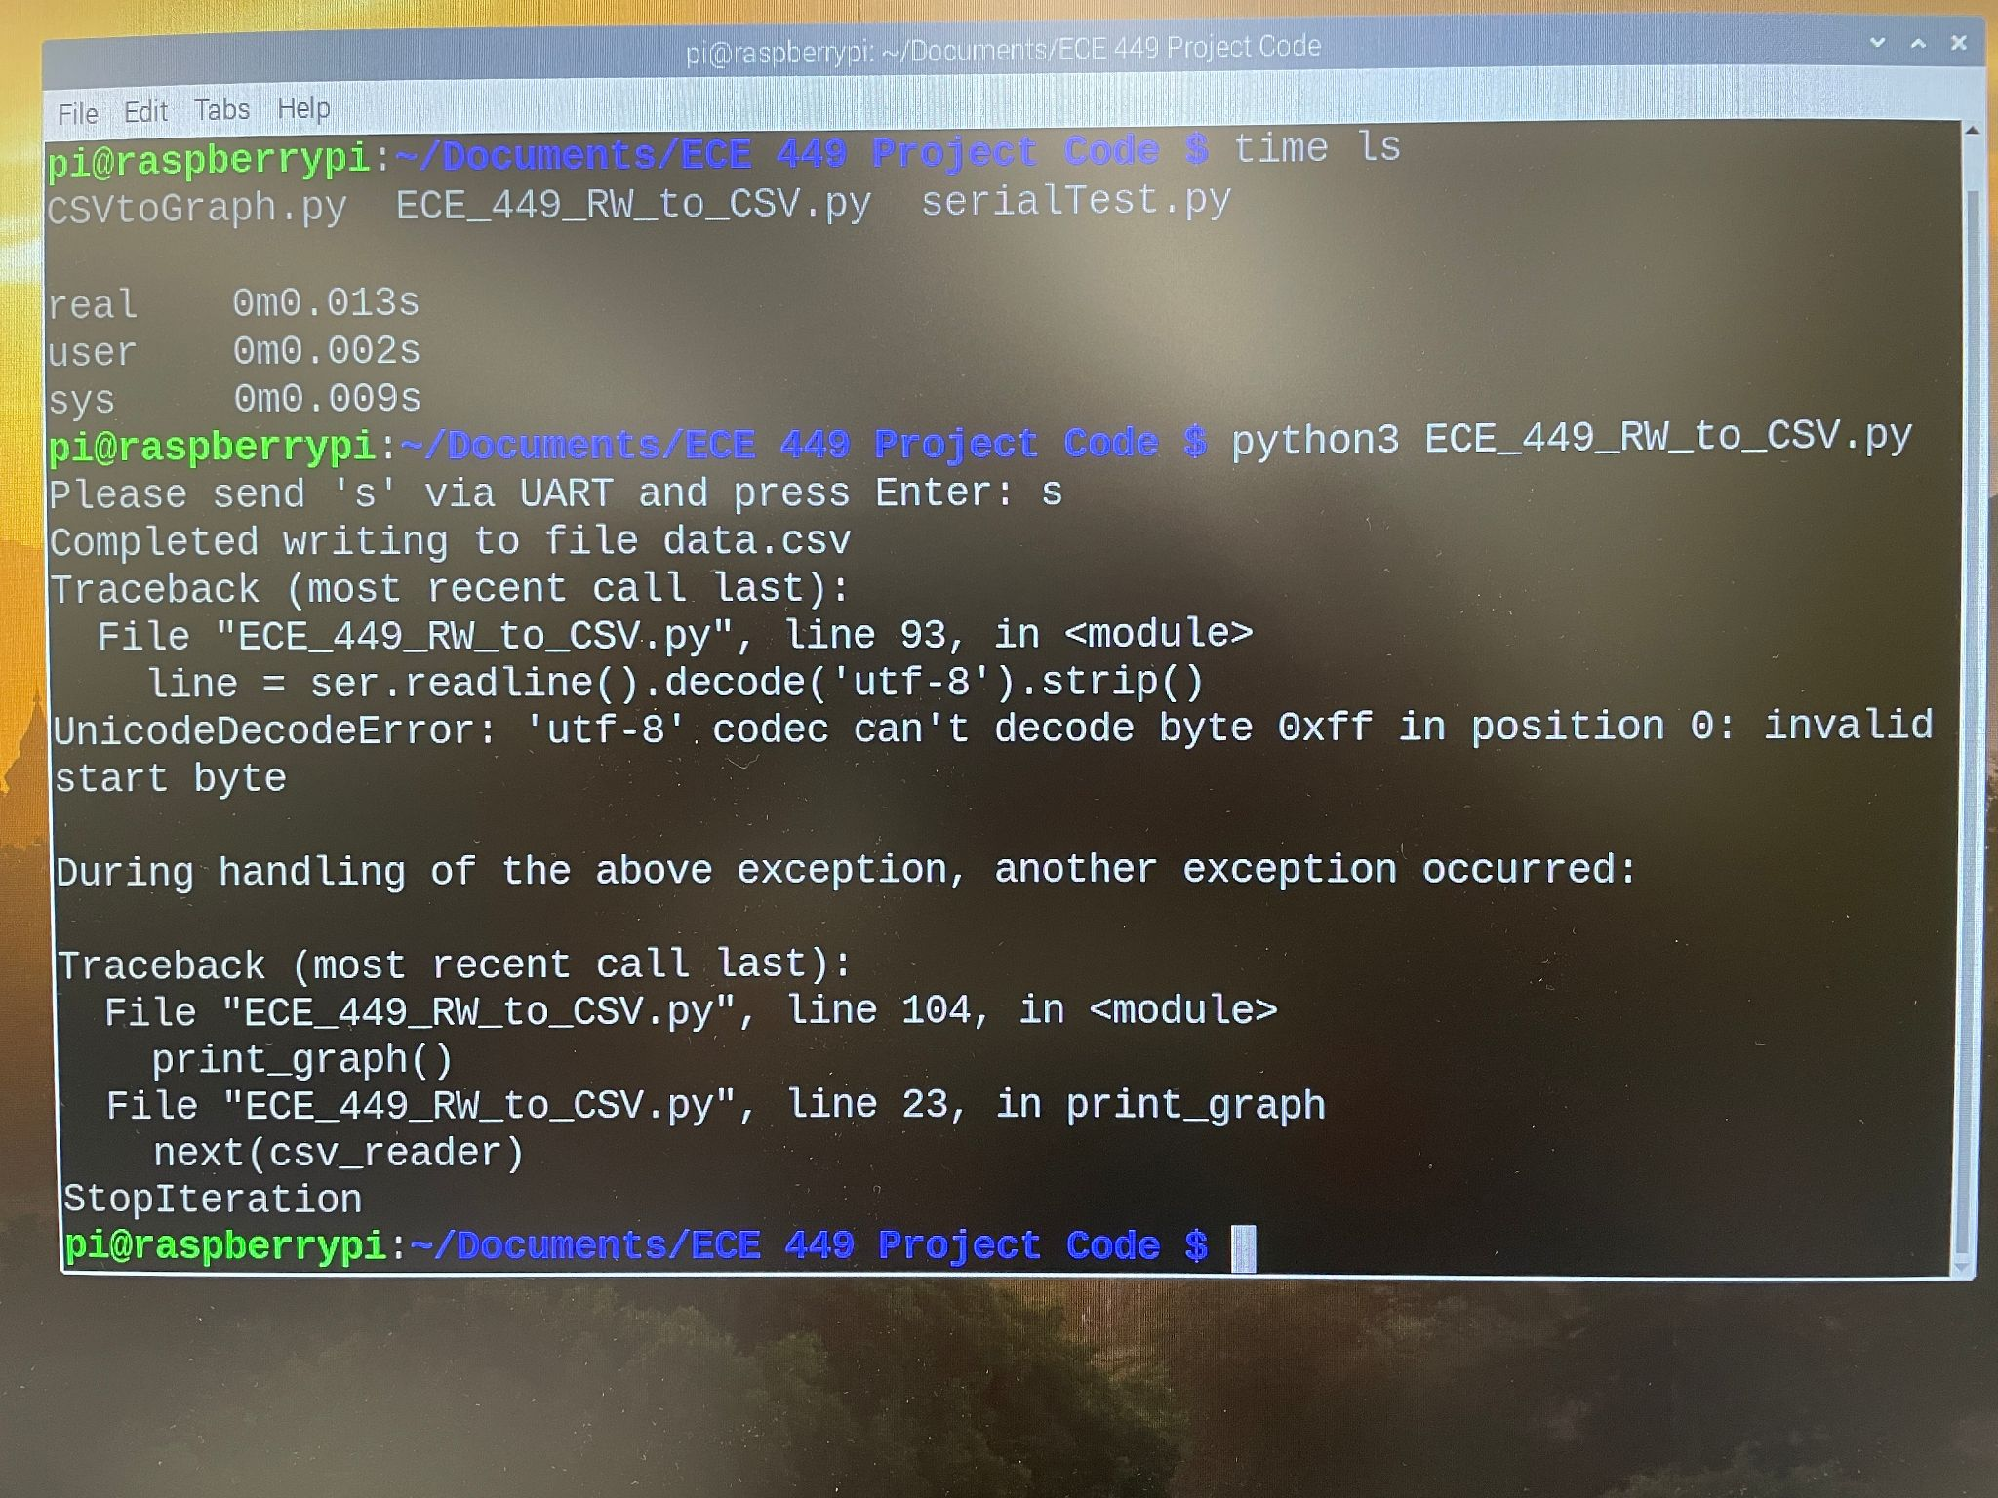
  + Nothing seems to be written to data.csv
  + No graphs created
  + REALIZATION: the signal wasn’t wired to the STM32 (smh claire)
    - But how did it run for 24 mins?? huh??
* Updated setup:
  + 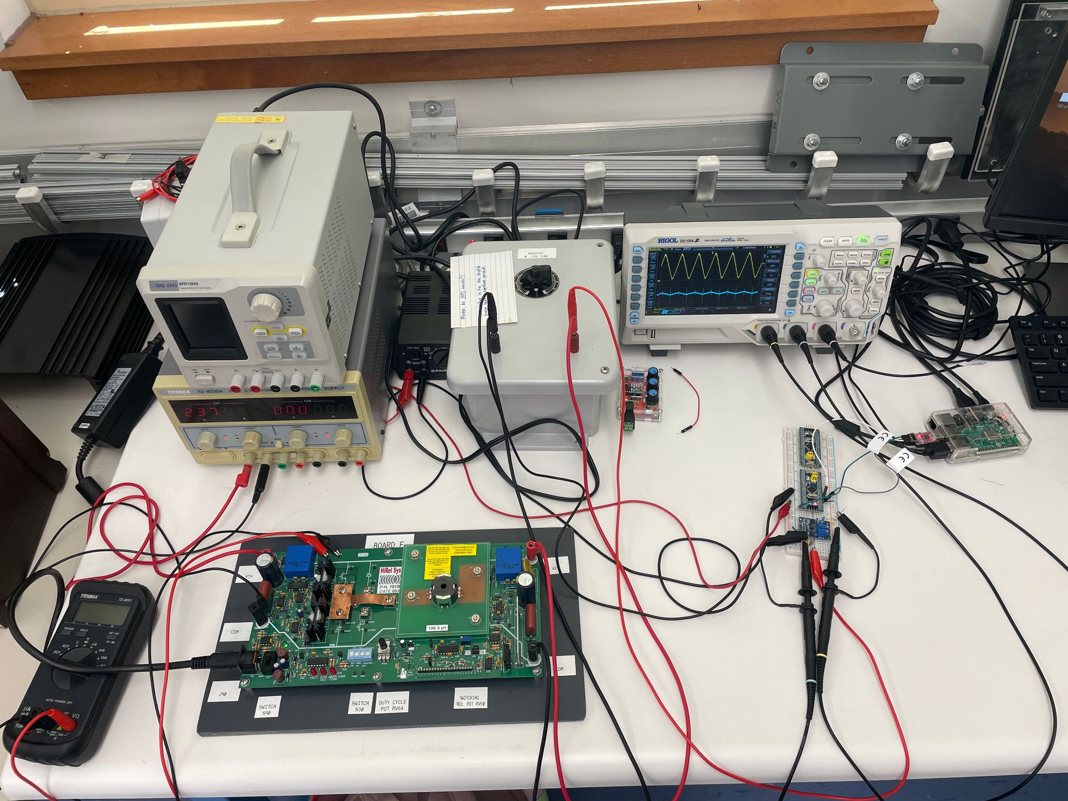
  + 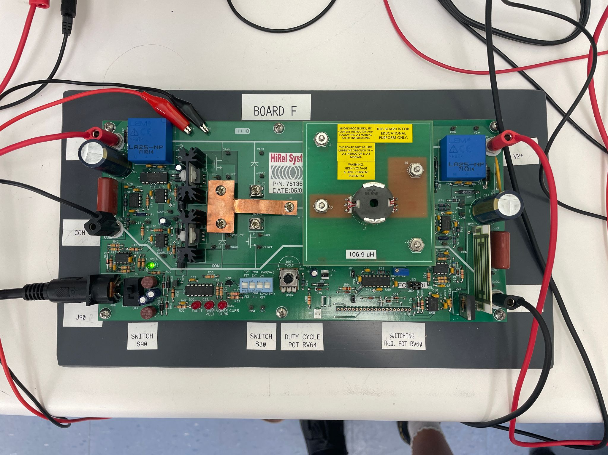
  + 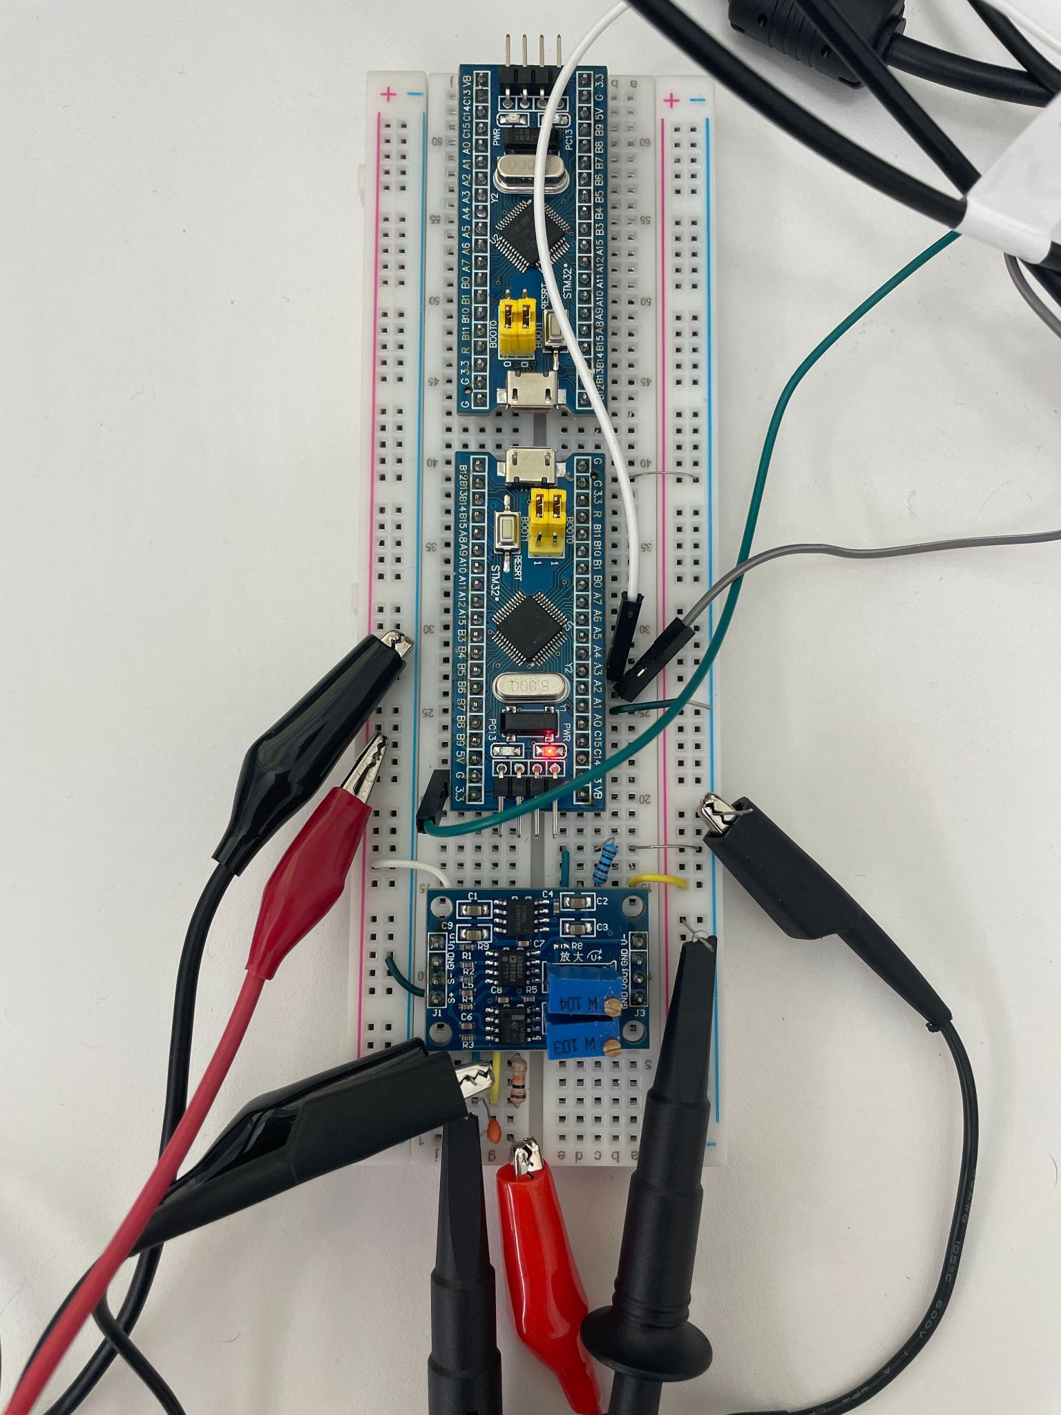
* When i send 3 V into the STM32, the output data.csv says all of the voltages are 4095 which is the max value for the 12 bit resolution, but 3/3.3 V should be like 3723
  + GOAL: figure this out
* Test: sending 1.5 V into STM32 and see if voltage levels change
  + 1.5 V didn’t work
  + 2.8 V & 0.2 A was minimum for making light flash on STM32, and program ran but still says voltages are 4095
* Next goal: figure out how to accurately reflect the voltage level in the data.csv

09/23/2024 Meeting with Dr. Scott:

* Test spare STM32
* Check STM32 debug tool
  + Can i sit there and adjust the voltage and see if anything is going on in the registers
    - Look at reg associated with ADC first

09/24/2024

* Oscilloscope readings were being wonky so i got new wires and they fixed the reading issues
* Programmed backup STM32 board with OG code, tested it with buck converter amped signal and 3V DC input, same issues
  + No results for buck converter signal, 4095 constant reading for 3V DC
* Guess i gotta debug :(

09/25/2024 meeting with dr scott:

* Read the manual
* Look at registers
* Look at STM32CubeF1 for examples
* Process:
  + Download software
  + Look at example
  + Read manual to understand process
* Maybe see about using ADC to adjust brightness of light using
* Contact alecea about walking through system

09/26/2024:

* STM32CubeF1
  + <https://www.st.com/en/embedded-software/stm32cubef1.html>
  + <https://github.com/STMicroelectronics/STM32CubeF1/tree/master>
* STM32F103C8T6 Blue Pill
  + <https://stm32-base.org/boards/STM32F103C8T6-Blue-Pill.html>
    - FLASH 64KiB
    - SRAM 20KiB
* STM32F103xx Manual
  + <https://www.st.com/content/ccc/resource/technical/document/reference_manual/59/b9/ba/7f/11/af/43/d5/CD00171190.pdf/files/CD00171190.pdf/jcr:content/translations/en.CD00171190.pdf>
    - Chapter 11: ADC
      * Medium-density devices are STM32F101xx, STM32F102xx and STM32F103xx microcontrollers where the Flash memory density ranges between 64 and 128 Kbytes.
      * ADC supply requirement: 2.4 V to 3.6 V
      * ADC input range: VREF- <= VIN <= VREF+
      * 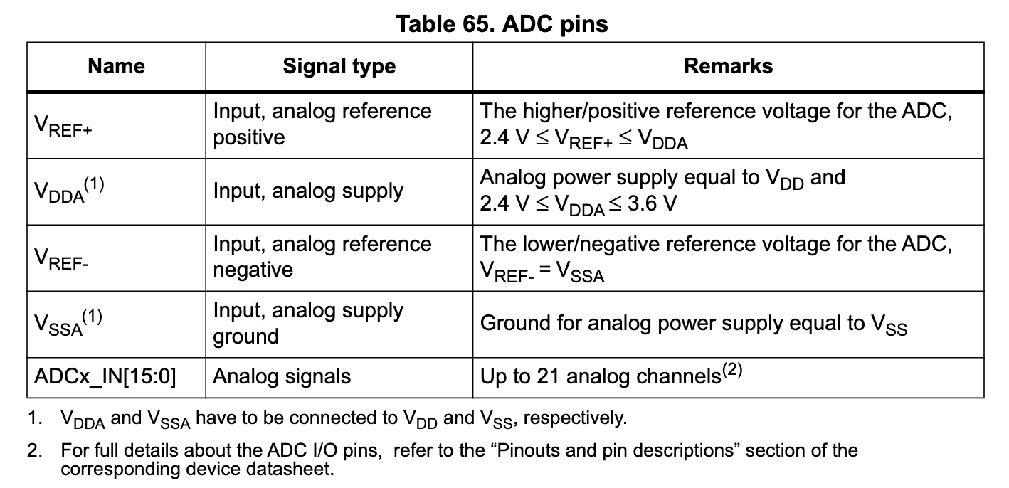
* 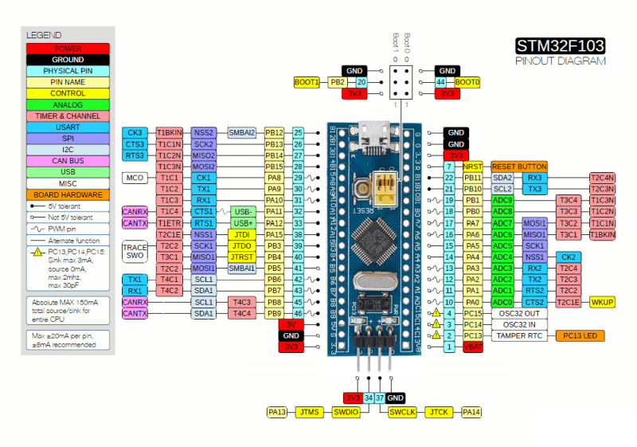
* Practice ADC: <https://microcontrollerslab.com/stm32-blue-pill-adc-polling-interrupt-dma/>
  + Also mentions to change the BOOT settings when programming
* Differentiates different BOOT settings: <https://www.electronicshub.org/getting-started-with-stm32f103c8t6-blue-pill/>

09/27/2024:

* Tried to upload [ADC/DMA](https://microcontrollerslab.com/stm32-blue-pill-adc-polling-interrupt-dma/) program thing to STM32, uploaded once, nothing happened, tried to upload again, ST-LINK link got errors:
  + Target no device found
  + Error in initializing ST-LINK device.
  + Reason: No device found on target.
* Tried to update ST-LINK, still got errors
* Tried backup ST-LINK, still got errors, updated it, still got errors
* DEPRESSION

09/30/2024:

* Dr scott said i dont seem like a taurus to him
* Also mercury is in super conjunction so that’s prob why my stuff didn’t work on friday and hopefully will work tomorrow

10/01/2024:

* Couldnt get ADC example to work
* Went back to original program, saw that ADC1 Ch1 was interfering with UART
  + Changed ADC1 Ch1 to Ch5
* Built program in programming BOOT, unplugged from computer, changed to operation BOOT, connected everything up (BUCK, filter, amp, pi), ran it, and error
* Thought the power light on the STM32 looked a little dim so plugged it into computer and lights lit up more with PC13 blinking now too which was good sign.
* Ran program, and it worked!!
  + 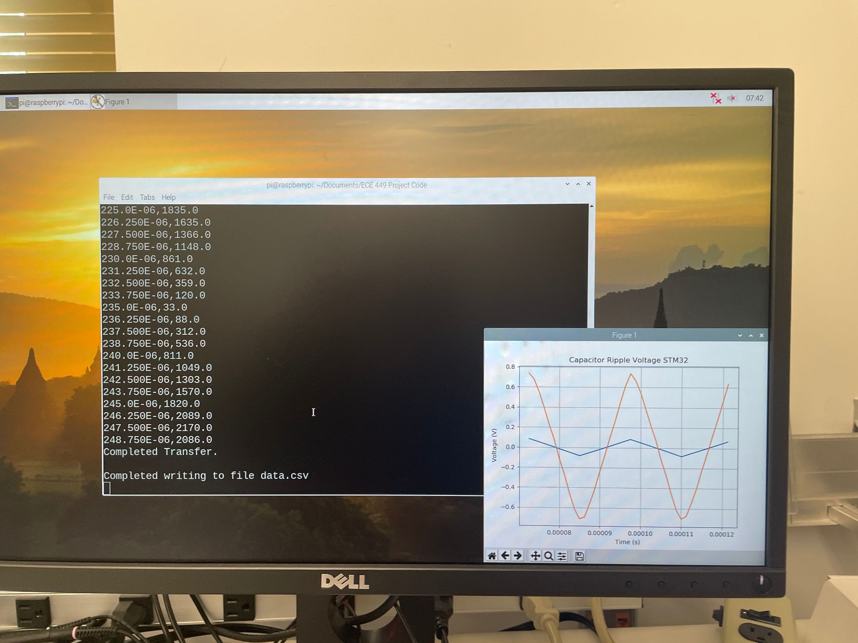
  + Next thing to look into is why the blue ripple is so small?
    - Wait, blue ripple is ideal, orange ripple is measured, which matches what the oscilloscope shows except it is centered about the origin here and not on the oscilloscope
* Next: look into python script and see if i should adjust it to better match the ripples in the graph?
* Next next: finally start looking into design choices and BOM
* Adjusted ADC to voltage calc line I had adjusted in python script back to original as shown in following picture, cap ripple voltage graph looks as expected now!
  + 
   